3801 Conductive nickel coating导电镍覆盖涂料

Conductive nickel coating导电镍覆盖涂料
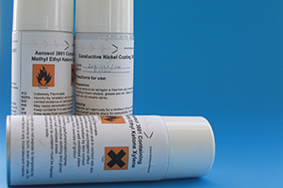
For Plastics用于塑料制品

A fast and easy way to shield plastic enclosures is by using a conductive paint containing nickel, copper or silver. The paint comes in aerosols for easy use, but can also be supplied in tins of 7 kg (3805) and 28 kg (3820) for larger quantities.
一个快的和容易的方法屏蔽塑料外壳是通过使用一个导电涂料包括镍，铜或银。该涂料以气雾剂的形式起作用为了容易使用，但也能被供应以罐kg (3805) 和 28 kg (3820)用于大批量。

The nickel conductive coating contained in an air-drying acrylic resin.镍覆盖涂料包含在一个空气干燥的丙烯酸树脂里。
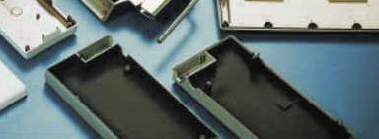
The resin becomes touch dry 15 minutes after application and achieves maximum conductivity within 24 hours. It is intended to prevent electrical interference, penetrating enclosures fabricated from thermoplastics and other insulating materials. The coating will also prevent static build up.
丙烯酸在应用15分钟后变为接触干燥，在24小时以内达到最大导电率。它计划用于预防电干扰，能刺入外壳焊接部位从热塑性塑料和其它的隔热材料。该涂料也将预防静电的增强。
It is recommended that an earth connection is made to achieve maximum shielding performance. A suitable material is copper shielding foil 3201 which may simply be pressed on or oversprayed. The applied coating has a matt grey textured finish.
它是被推荐的，做一个接地线以实现最大的屏蔽性能。一个合适的材料是铜屏蔽铜箔3201，可以简单的被用力压或被超范围的喷涂。使用的涂料有一个无光泽灰色斑纹漆。

Benefits好处:
- Low surface resistivity of 0.9Ω/sq giving a high attenuation
- 低的表面电阻系数0.9Ω/sq，给出一个高衰减。
- Aerosol enables speed and ease of coverage of complex shapes
- 喷雾剂能够加速和容易地覆盖复杂的形状。
- Delivery from stock
- 有现货库存可及时交货

Shielding performance屏蔽性能
Frequency (Mhz) 频率 | Reduction (dB) 减少
30 | 36
100 | 38
200 | 44
500 | 54
700 | 54
900 | 50
See Guarantee

Example举例
Part numbers of conductive coating and glue.导电涂料和胶水的零件号

Part number零件号
3801
3801 : Aerosol 喷雾剂365 ml
3805 : Tin锡 5 liters升 (7kg)
3820 : Tin锡 20 liters升 (28Kg)
3838 : Conductive metallization导电金属覆料
3850 : Silver coating 50gr 银涂料
3980 : Conductive adhesive 50gr 导电粘合剂

