3838 Conductive Metallisation导电喷涂金属粉

Conductive metallisation 3838导电喷涂金属粉
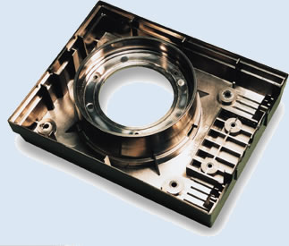
For higher demands and larger quantities we can sputter a full metal coating on 90% of all commonly used plastics, even on PTFE! Applied as a sandwich of three thin layers of metal.
对于更高要求和大量的使用我们能喷射一个完全金属涂层在90%的所有通常使用的塑料制品上，即使在PTFE上！应用作为一个三个金属薄层的三明治。
First a thin layer of stainless steel, to prevent the softeners in the plastic affecting the shielding. Secondly a thin layer of copper for superb shielding performance. And thirdly another layer of stainless steel to avoid corrosion.
第一个薄层是不锈钢的，用于防止软化剂在塑料里影响屏蔽。第二个薄层是铜的，用于杰出的屏蔽效能。第三个薄层是不锈钢的，用于规避腐蚀。

Shielding performance屏蔽性能
Frequency (Mhz)频率 | Metallisation (dB)喷涂金属粉
30 | 50
100 | 58
200 | 70
500 | 74
700 | 72
900 | 70
See Guarantee

