3850 Conductive Silver Coating导电银涂料

Conductive Silver Coating 3850导电银涂料
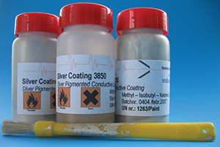
Silver pigmented conductive coating银色导电涂料

Silver coating 3850 is the latest in a series of coatings which provide electromagnetic compatibility (EMC). This product has been specifically designed to offer increased coverage while maintaining very high conductivity.
银涂料3850在涂料系列里是最新的，提供电磁兼容性（EMC）。当需要供给非常高的导电率时这个产品是特别设计用于提供增强的覆盖。
This it is a very economic means of achieving excellent shielding against emitted electromagnetic interference (EMI).
这是一个非常经济的方法以实现卓越的屏蔽性能以防止发出电磁干扰（EMI）。
This coating retains its low resistance even after exposure to heat, cold, humidity and salt spray. It is an air drying system that requires no primer or top coat.
这个涂料保持了它的低的阻抗即使在暴露到热，冷，潮湿和盐末之后。它是一个空气干燥系统，要求没有底漆或面漆。
It is easily applied by spray or brush and is compatible with plastics commonly used for electronic equipment enclosures.
它是容易应用的通过喷射或刷，及适合于塑料制品，通常应用于电子设备外壳。

Benefits好处
- Excellent conductivity 卓越的导电率
- Very smooth, bright coating 非常光滑，明亮的涂层
- Meets UL specification 746-C 符合UL规范746-C
- Overspray easily removable with MEK 超范围的喷涂容易去除用丁酮
- Excellent adhesion to substrates such as polycarbonate, ABS, polystyrene and PC/ABS blends

Curing固化
Silver coating dries in 4 to 16 hours of air drying.镀银层空气干燥需要4到16个小时。
It may be force dried for 20 minutes at 60-70ºC。它可以被强制干燥用20分钟在60-70ºC。

Example举例
Part number of conductive silver coating.导电镀银层的零件号
Part number零件号 | Amout
3850 | 1
 | Specify the amount you need?你需要指定数量

