Clip on gasket 6500夹式垫圈

Clip-on EMI gaskets with water seal夹式EMI垫圈带水封

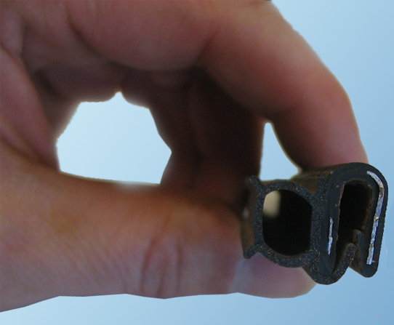
Clip-on shield 6500夹式屏蔽
This range of easily mounted clip-on gaskets is composed of a separate sponge rubber water seal and an EMI-shielding side of highly conductive, wear-resistant metallized fabric. The construction is very flexible thanks to the hollow rubber, so a low closure force is guaranteed.
这个系列的容易装配的夹式垫圈的组成由一个分开的海绵状橡皮水封和一个高导电的EMI屏蔽侧边，抗磨损的用金属处理的织物。结构是非常柔软的，由于空的橡胶，因此确保了一个低的闭合力。
The gasket is assembled without tools, simply by pressing the section by hand onto the metal flange of you enclosure. Different sizes are available on request. The gasket can make angles in two planes where a small radius is sufficient. Temperature range from -40° tot +110° C. A flame retardant version (UL94 V0) is also available (see on the picture below).
该垫圈的装配不用工具，简单的通过压线段用手在你的机壳的凸缘的上面。不同的尺寸根据需要可获得。该垫圈能在两个位面里做成角度，这里一个小的半径是足够的。温度范围从-40°到+110° C。一个阻燃剂版本(UL94 V0)也是可获得的（看下面的图片）。

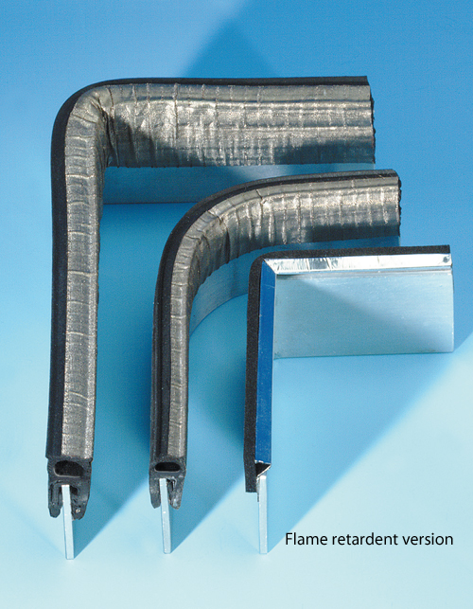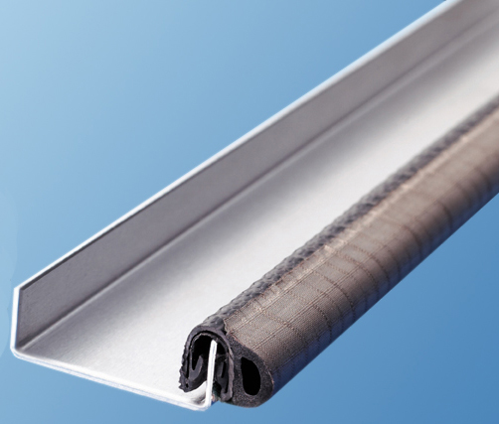

Dimensions尺寸 | 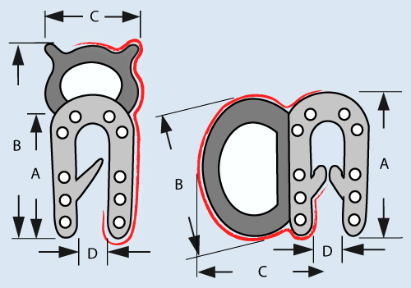
  Profile剖面 | A | B | C | D
  Profile剖面 | (mm) | (mm) | (mm) | (mm)
  6585 | 9 | 16 | 9 | 0.5-2.0
  6590 | 10 | 21 | 11 | 1-3
  6595 | 9,5 | 9 | 8,7 | 0.5-2.0

6590  Big clip-on shield大的夹式屏蔽 | 6585  Small clip-on shield小的夹式屏蔽 | 6595  Side clip-on shield侧面夹式屏蔽
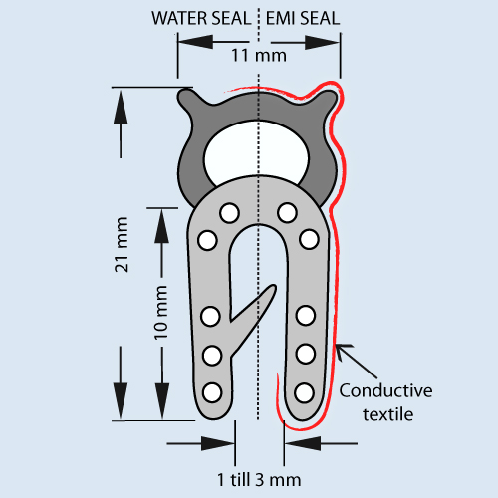 | 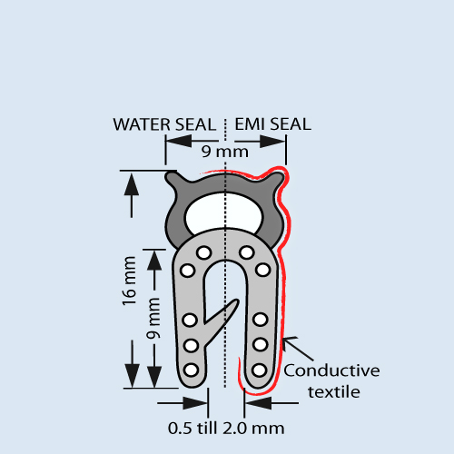 | 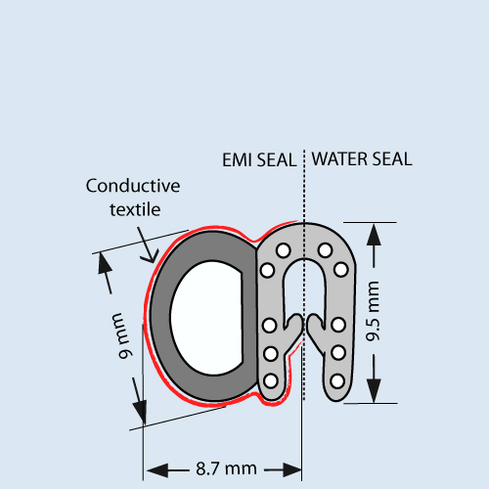

Shielding Performance屏蔽性能
Shielding effectiveness depends on surface, shape of gaskets and materials used屏蔽效能依据表面，垫圈的形状和所有的材料。
Frequency Hz频率 | Mode | Attenuation dB衰减
1M | E | 121
10M | E | 110
100M | E | 103
400M | E | 98
1G | P | 93
10G | P | 90
See Guarantee

Example举例
Please indicate the profile number followed by the length in meters.请指定剖面号，长度是米。

Profile剖面 | Length (m)长度
6585 | 10
6585 : Small clip-on shield小的夹式屏蔽  6590 : Big clip-on shield大的夹式屏蔽  6595 : Side clip-on shield侧面夹式屏蔽 | Please specify the length in meters请用单位米指定长度

