Amucor Shield 6800屏蔽

Amucor EMI shield is for panels and screwed applications该EMI屏蔽是用于面板和螺丝拧紧的应用
Amucor Shield 6800 is an economical HF gasket which can be supplied in a wide range of dimensions. It is very effective in combination with zinc-plated steel and aluminium constructions.  Amucor Shield 6800是一个经济的HF垫圈，能有一个宽范围尺寸的供货。它是非常有效的与锌板钢和铝结构结合。  All gaskets can be provided with a (conductive) self-adhesive strip.  所有的垫圈能被供应带一个(导电)自粘条。  Amucor Shield 6800 consists of a neoprene or PVC foam core covered with reinforced foil, based on an Amucor alloy. This guarantees excellent shielding performance and very great strength.  Amucor Shield 6800由一个氯丁橡胶或PVC泡沫核覆盖有加固薄片组成，基于一个Amucor合金。这个确保卓越的屏蔽性能和非常大的强度。  For special applications, different foam cores and conductive foils and fabrics are available.  对于特殊的应用，不同的泡沫核和导电薄片和织物可获得。 | 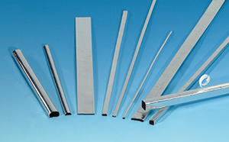  Flat panels and screwed applications. With and without self adhesive strip.平板和螺丝拧进的应用。带有和不带有自粘条。
Shielding performance屏蔽性能  Shielding effectiveness depends on surface, shape of gaskets and material used.  屏蔽效率依据垫圈的表面、形状和使用的材料。 | 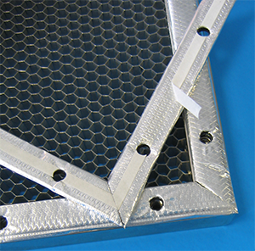  Amucor gasket used on a Honeycomb ventilation panel  Amucor垫圈使用在一个蜂窝通风面板上
  Frequency频率Hz | Mode | Screening dB屏蔽
  1M | E | 121
  10M | E | 110
  100M | E | 103
  400M | E | 98
  1G | P | 92
  10G | P | 89
  See Guarantee
Benefits好处  - Self-adhesive EMC gasket 自粘EMC垫圈  - Easy to fit, can be cut with scissors 容易安装，能用剪刀剪切  - Good water resistance 良好的抗水性  - Gasket can be die-cut (screw holes) 垫圈能被冲切（螺丝孔）  - Roll length up to 50, 100, 250 or 1000 m 卷的长度可达50,100,250或1000米。  - High shielding performance 高的屏蔽性能  - Low closure force 低的闭合力  - EXTREMELY STRONG; 非常牢固  - Deflection屈折 50% | 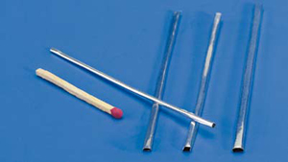  Very small Amucor gasket, 1mm width and 1mm high versions are available  非常小的Amucor垫圈，1mm宽度和1mm高度的版本可获得
Options选件  - Cut into accurate lengths 切成精确的长度  - Can be made die cut or as frame 能被做冲切或作为框架  - Combination with water seal 与水封结合  - UL94V-0 flame retardant foam core 阻燃剂泡沫核  - Chemical resistant rubbers like EPDM 耐化学橡胶，如EPDM  - Silicone sponge for high temperatures up to 220°C;  - 硅树脂海绵用于高温直到220°C;  - Different conductive foils and fabrics  - 不同的导电箔和织物 | 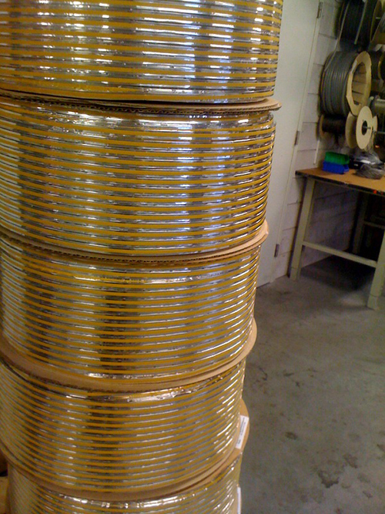  Amucor shield can be delivered on rolls, worldwide delivery
Mechanical properties机械性能  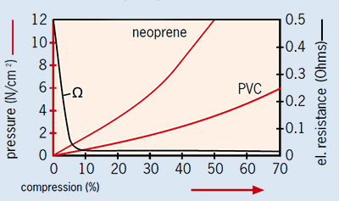 | Standard gasket dimensions标准垫圈尺寸  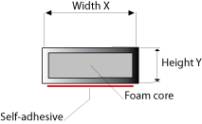
Dimensions尺寸
Width X(mm)宽度
Height高度 Y(mm)
Height高度 Y(mm) |  | 2 | 3 | 4 | 5 | 6 | 7 | 8 | 10 | 12 | 15 | 18 | 20 | 25 | 32 | 50
Height高度 Y(mm) | 1 | 6821 | 6831 | 6841 | 6851 | 6861 | 6871 | 6881 | 68101 | 68121 | 68151 | 68181 | 68201 | 68251 | 68321 | 68501
Height高度 Y(mm) | 2 | 6822 | 6832 | 6842 | 6852 | 6862 | 6872 | 6882 | 68102 | 68122 | 68152 | 68182 | 68202 | 68252 | 68322 | 68502
Height高度 Y(mm) | 3 |  | 6833 | 6843 | 6853 | 6863 | 6873 | 6883 | 68103 | 68123 | 68153 | 68183 | 68203 | 68253 | 68323 | 68503
Height高度 Y(mm) | 4 |  |  | 6844 | 6854 | 6864 | 6874 | 6884 | 68104 | 68124 | 68154 | 68184 | 68204 | 68254 | 68324 | 68504
Height高度 Y(mm) | 5 |  |  |  | 6855 | 6865 | 6875 | 6885 | 68105 | 68125 | 68155 | 68185 | 68205 | 68255 | 68325 | 68505
Height高度 Y(mm) | 6 |  |  |  |  | 6866 | 6876 | 6886 | 68106 | 68126 | 68156 | 68186 | 68206 | 68256 | 68326 | 68506
Height高度 Y(mm) | 8 |  |  |  |  |  | 6878 | 6888 | 68108 | 68128 | 68158 | 68188 | 68208 | 68258 | 68328 | 68508
Height高度 Y(mm) | 10 |  |  |  |  |  |  |  | 681010 | 681210 | 681510 | 681810 | 682010 | 682510 | 683210 | 685010
Height高度 Y(mm) | 12 |  |  |  |  |  |  |  |  | 681212 | 681512 | 681812 | 682012 | 682512 | 683212 | 685012
Item marked bold are 98% stock items. Other dimensions on request.
项目记号黑粗体的是98%存货项目。其它的尺寸根据需求。

Tape Specification粘合带规格说明
- 01 : standard self-adhesive placed in the middle 标准自粘放置在中部
- 02 : without self-adhesive 不带有自粘
- 03 : with conductive self-adhesive 带有导电自粘
- 06 : standard self-adhesive, asymmetrical 标准自粘，不对称的
- 07 : standard self-adhesive placed on the side 标准自粘放置在侧面上

Foam Specification泡沫规格
- N : Standard Neoprene Foam 标准氯丁橡胶泡沫
- E : EPDM foam core 三元乙丙橡胶泡沫核
- P : low closure force PVC foam, slow recovery 低闭合力PVC泡沫，慢复原
- F : flame retardant UL94V-0 foam 阻燃剂UL94V-0泡沫

Example举例
When you order Amucor shield 6800, 8 x 2 mm, standard self-adhesive placed in the middle, standard neoprene foam core: 6882-01-N
当你订购Amucor shield 6800, 8 x 2 mm,标准自粘放置在中部，标准氯丁橡胶泡沫核：6882-01-N
Part number零件号 | Tape code带编码 | Foam code泡沫编码
6882 | 01 | N
 | 01 : standard self-adhesive placed in the middle 标准自粘放置在中部  02 : without self-adhesive 不带有自粘  03 : with conductive self-adhesive (only recommended on small sizes) 带有导电自粘（仅被推荐在小尺寸上）  06 : standard self-adhesive, asymmetrical标准自粘，不对称的  07 : standard self-adhesive placed on the side标准自粘放置在侧面 | N : standard neoprene foam标准氯丁橡胶泡沫  E : EPDM foam core三元乙丙橡胶核  P : PVC foam, slow recovery聚氯乙烯泡沫，慢复原  F : flame retardant UL94V-0 foam阻燃剂UL94V-0泡沫

