1200 Metal knit gasket金属编织垫圈

Knitted Mesh is a Universal EMC gaskets to shield lower frequencies编织网是一个通用的EMC垫圈以屏蔽较低的频率。
For permanent or fixed panel mating surfaces.用于永久的或固定的面板接触面。

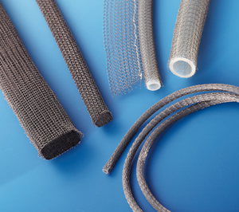
The 1200 metal knit gasket serie EMC gaskets consist of a layer of knitted metal wires over a low-closure-force rubber or elastomer core. For applications like EMP or high temperatures a full metal version is available. Metal knit gasket is sometimes combined with an environmental seal to provide IP rating, depending on the materials used.
该1200金属编织垫圈系列EMC垫圈由在一个低闭合力橡胶或弹性体核上面有一层编织金属线组成。对于应用如EMP或高温，可获得一个全金属版本。金属编织垫圈有时与一个环境密封结合以提供IP等级，依据使用的材料。
The temperature resistance depends on the core material of the metal knit gasket, but ranges from -60°C to 220°C are possible. These metal knit gaskets are insensitive to external influences and can withstand harsh conditions very well.
耐温性依据金属编织垫圈的核材料，但范围从-60°C to 220°C是可能的。这些金属编织垫圈是不易感受外部影响的，能非常好的承受严厉的条件。
The maximum deflection with a sponge elastomer core is approximately 30%, with hollow extrusion 50%. This is why the hollow type is used more often.
最大挠度用海绵弹性体核的大约是30%，用空心弹性体的是50%。这是为什么空心类型的通常使用的更多的原因。
For high frequency shielding, foil-based gaskets like Amucor Shield 6800 will perform better, because of their much larger contact surface. Please take a look at the image below to understand.
对于高频屏蔽，基于薄片的的垫圈如Amucor Shield 6800将执行的更好，因为它们有跟大的接触面。请注视下列的图形可明白。
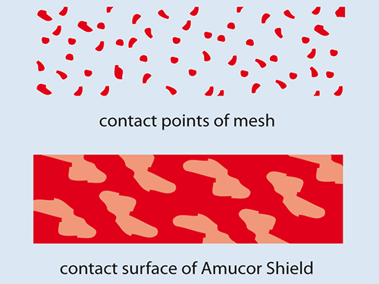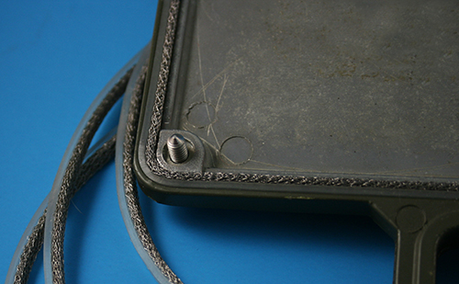
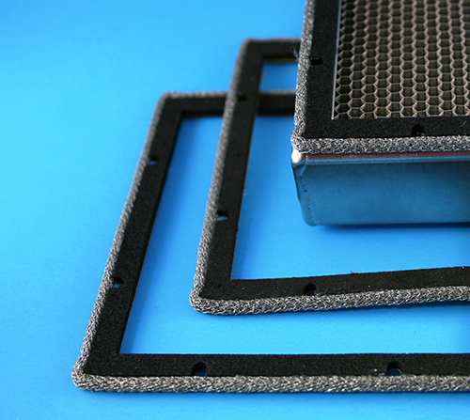
Advantages优势:
- High attenuation level for lower frequencies; 对于低频有高的衰减级别。
- Suitable for use under extreme conditions (military applications) 适合于使用在最恶劣的条件下（军事应用）
- Wear resistant; 耐磨
- Insensitive for corrosion;耐腐蚀

Technical specifications技术规格
Material材料 | Applications应用
Monel蒙乃尔铜-镍合金  Per QQ-N-281  BS 3075 N A 13  Class A  diameter直径 0.11mm | The most common used material.最普遍使用的材料  Insensitive to corrosion and neutral on the galvanic scale.不受腐蚀的影响及是中性的在电化氧化方面。
Aluminium铝  AMS 4187  BS 1475 5056A  Alloy 合金5056  diameter 直径0.13mm | Is used in some cases for aluminium enclosures.用于铝外壳的一些情况。  Aluminium can be chromated with an Alchrome 1200 layer, if necessary.
T.C.S.  Steel Core钢心(57%)  Copper cladding铜镀层(40%)  Tin Plating镀锌板 (3%)  diameter直径 0.11mm | This material has excellent magnetic as well as electrical properties, because a Ferro alloy is covered with copper.这个材料有卓越的磁和电特性，因为一个一个亚铁合金被用铜覆着。  The outside is tinned to prevent corrosion. 外部是镀锡的以预防腐蚀。
Stainless steel不锈钢  AISI 304  diameter直径 0.13mm | The strongest material with a shielding performance that can be compared with aluminium. High resistance against wear.最强的屏蔽性能的材料与铝相比。高的耐磨性。

Shielding performance屏蔽性能
Frequency频率 | Field场 | Monel蒙乃尔铜镍合金 | Aluminium铝 | TCS | S/Steel不锈钢
10 KHz | H | 45 | 40 | 60 | 40
100 KHz | H | 49 | 45 | 65 | 44
1 MHz | H | 60 | 60 | 85 | 58
1 MHz | E | 125 | 125 | 125 | 125
10 MHz | E | 120 | 120 | 120 | 120
100 MHz | E | 100 | 100 | 108 | 100
400 MHz | P | 98 | 95 | 99 | 94
1 GHz | P | 85 | 76 | 78 | 76
10 GHz | P | 80 | 65 | 62 | 60

Stock dimensions存储尺寸
 | 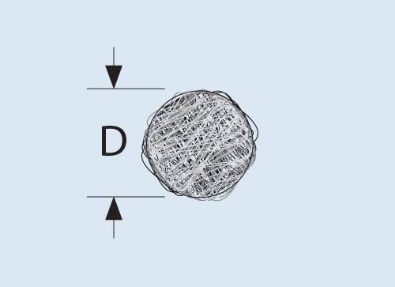 |  | 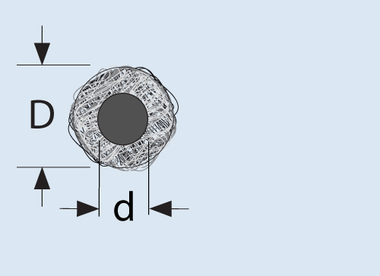  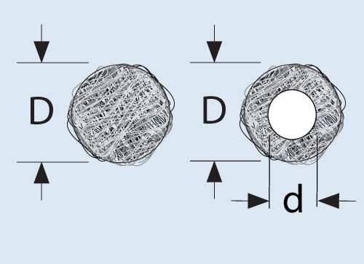
  Fully metal round (R)完全的金属环
  D (mm)
  1.6
  2.4
  3.2
  4.0
  4.8
  6.4
  7.9
  9.5
  11.1
  12.7
  Hollow round (HR)空心环
  D x d (mm)
  3.2 x 1.6
  4.8 x 3.2
  6.4 x 3.2
  8.0 x 4.8
  9.5 x 6.4
  11.1 x 8.0
  12.7 x 9.5
  14.9 x 11.1
 | 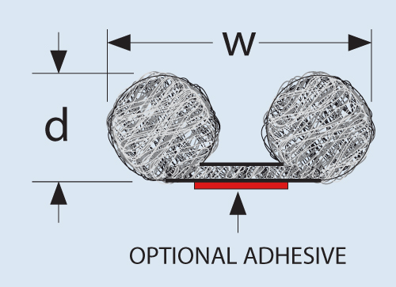 |  | 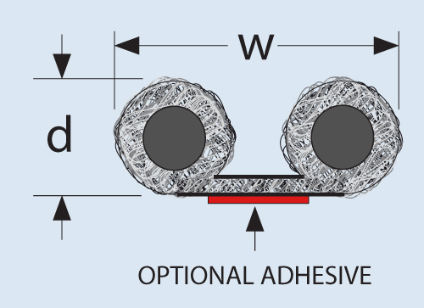  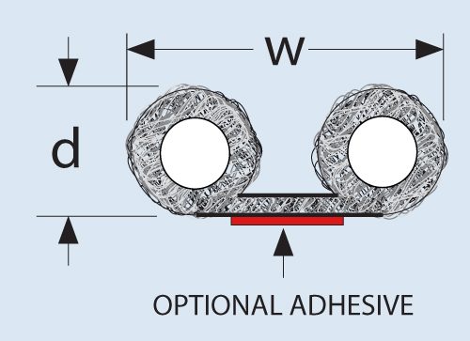
  Double fully metal round (B)双全金属环
  d x w (mm)
  1.6 x 9.5
  1.6 x 12.7
  1.6 x 15.9
  2.4 x 12.7
  3.2 x 9.5
  3.2 x 12.7
  3.2 x 15.9
  4.8 x 15.9
  4.8 x 19.1
  4.8 x 25.4
  6.4 x 15.9
  6.4 x 19.1
  6.4 x 25.4
  12.7 x 25.4
  Double hollow round (HB)双空心环
  d x w (mm)
  3.2 x 9.5
  3.2 x 12.7
  3.2 x 15.9
  4.8 x 15.9
  4.8 x 19.1
  4.8 x 25.4
  6.4 x 15.9
  6.4 x 19.1
  6.4 x 25.4
  9.5 x 25.4
  12.7 x 25.4
 | 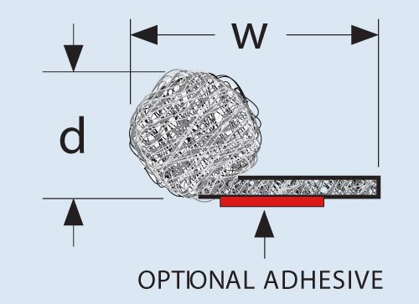 |  | 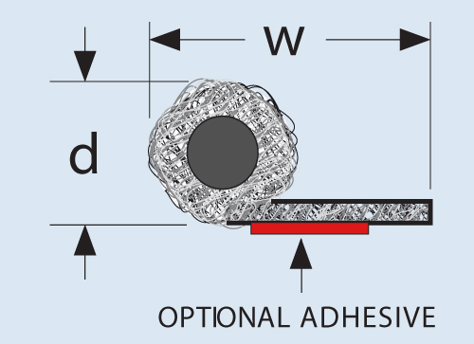  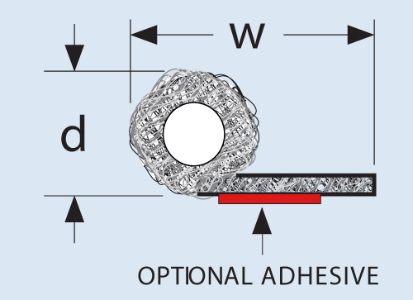
  Fully metal round with
  tail (T)全金属环带有尾巴
  d x w (mm)
  1.6 x 9.5
  1.6 x 12.7
  1.6 x 15.9
  2.4 x 12.7
  2.4 x 15.9
  3.2 x 12.7
  3.2 x 15.9
  3.2 x 19.1
  4.0 x 12.7
  4.0 x 19.1
  4.8 x 15.9
  4.8 x 19.1
  4.8 x 25.4
  6.4 x 15.9
  6.4 x 19.1
  6.4 x 25.4
  7.9 x 15.9
  7.9 x 19.1
  7.9 x 25.4
  9.5 x 15.9
  9.5 x 19.1
  9.5 x 25.4
  11.1 x 19.1
  11.1 x 25.4
  12.7 x 19.1
  12.7 x 25.4
  Hollow round with tail (HT)空心环带有尾巴
  d x w (mm)
  1.6 x 12.7
  1.6 x 15.9
  1.6 x 19.1
  2.4 x 12.7
  2.4 x 19.1
  3.2 x 12.7
  3.2 x 16.0
  3.2 x 19.1
  4.0 x 12.7
  4.0 x 19.1
  4.8 x 12.7
  4.8 x 15.9
  4.8 x 25.4
  6.4 x 12.7
  6.4 x 15.9
  6.4 x 19.1
  6.4 x 25.4
  9.4 x 19.1
  9.4 x 25.4
 | 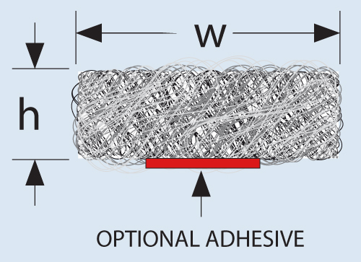 |  | 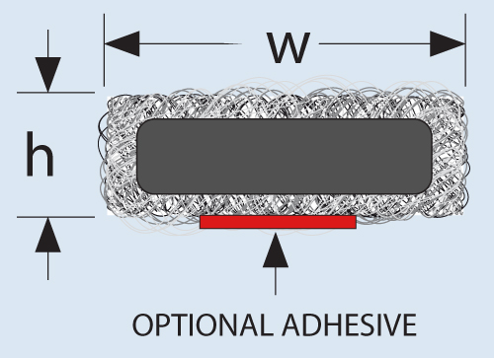
  Full metal rectangular (S)
  全金属矩形
  w x h (mm)
  3.2 x 1.6
  3.2 x 3.2
  3.2 x 4.0
  3.2 x 4.8
  3.2 x 6.4
  4.8 x 4.8
  6.4 x 1.6
  6.4 x 3.2
  6.4 x 6.4
  9.5 x 6.4
  12.7 x 6.4
  12.7 x 9.5
  12.7 x 12.7
  15 x 6
  15 x 8
  15 x 10
  15 x 12
  15 x 15
  15.9 x 9.5
  19.1 x 12.7
  20 x 6
  20 x 8
  20 x 10
  20 x 12
  20 x 20
  25 x 6
  25 x 8
  25 x 10
  25 x 12
  25 x 18
  25 x 20
  Hollow rectangular (HS)
  空心矩形
  w x h (mm)
  2.4 x 3.2
  2.4 x 4.8
  2.4 x 6.4
  3.2 x 3.2
  3.2 x 4.8
  3.2 x 6.4
  3.2 x 9.5
  4.8 x 4.8
  4.8 x 6.4
  4.8 x 9.5
  6.4 x 6.4
  6.4 x 9.5
  6.4 x 12.7

All knitted mesh gaskets can be produced with water seal.所有的编织网垫圈能被扩展水封。
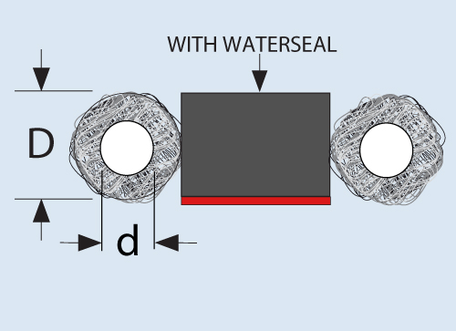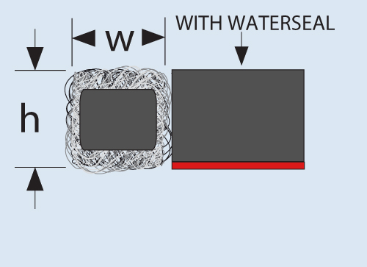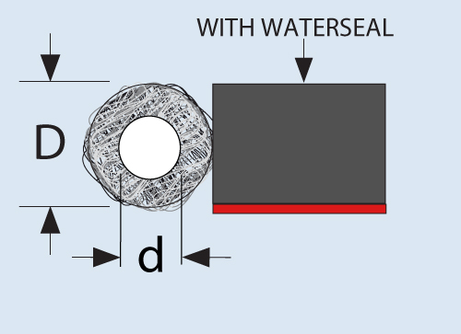

Example举例
1200 Series metal knit gasket, neoprene core with monel cover, hollow rectangular shape, 3.2 x 1.6 mm with standard 10 mm width waterseal
1200系列金属编织垫圈，氯丁橡胶核带有蒙乃尔合金覆着，空心矩形形状，3.2 x 1.6 mm带有标准的10mm宽度水封。

Serie系列 | Core核心 | Material材料 | Shape形状 | Dimensions尺寸 | Waterseal水封 | Width宽度 (mm)
1200 | C | M | HS | 3.2 x 1.6 | S | 10
 | N : Not important不重要  F : Full metal全金属  H : Hollow silicone空心硅树脂  C : Neoprene氯丁橡胶  S : Sillicone硅树脂  E : EPDM三元乙丙橡胶  O : Hollow空心 | N : Not important不重要  M: Monel蒙乃尔铜镍合金  T : TCS  A : Alluminium铝  S : Stainless stell不锈钢  E : Steel钢 | R : Fully metal round全金属环  HR : Hollow round空心环  B : Double fully metal round双全金属环  HB : Double hollow round双空心环  T : Fully metal round & tail全金属环带尾巴  HT : Hollow round & tail空心环带尾巴  S : Fully metal rectangular全金属矩形  HS : Hollow ractangular空心矩形 | Give the dimension from the dimension table  从尺寸表中给出尺寸 | S : Standard waterseal标准水封  P : Soft "P" seal软的密封  N : No waterseal没有水封 | Specify the width of the waterseal in mm  用毫米单位指定水封宽度

