7500 L-shape Water/EMI seal for thin doors and lids. L型水密及EMI密封用于薄的门和盖子

7500 series Water/EMI seal for thin doors. 7500系列 及EMI密封用于薄的门
Product discription产品描述
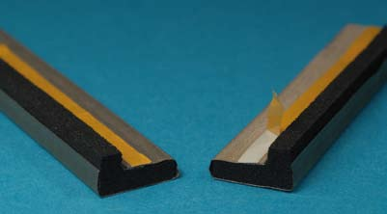
We have developed this L-shaped gasket to make an efficient combined seal for doors and lids. This L-shaped gasket is used to achieve two goals at once. A water seal and an EMI seal.
我们发展这个L型垫圈去做一个高效率的组合的密封用于门和盖子。这个L型垫圈被用于一次实现两个目的。一个水封和一个EMI密封。
This L-shaped gasket is made from a whole piece of neoprene foam. One side has been laminated with conductive (the conductive side) and the other side is blank neoprene that is provides a water seal.
The flange of the door will compress the water seal side of the gasket with very little force to realize a watertight seal.
这个L型垫圈由一个整块的氯丁橡胶泡沫制成。一侧用导电叠压（导电侧）和另一边是空白的氯丁橡胶以提供水封。
门的凸缘将压紧在垫圈的水封侧，用非常小的力以实现一个水的密封。
The electrical conductive part on the other side of the gasket makes an electrical connection between the door and the leaf of the door.
电传导部分在垫圈的另一侧上，在门和门的端结点之间做一个电连接。
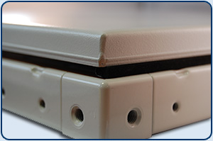
In the above picture you will see a closed lid with the gasket mounted on the inside of the lid. Please see the video on the right side for more information.
在上面的图片里你将看到一个闭合的盖子，带有垫圈装配在盖子的内侧。
The gasket will realize a perfect airtight locking and makes at the same time an electrical contact on the inside of the housing. The electrical contact is free of water and dust.
该垫圈将实现一个完全密封的锁闭，与此同时一个电接触在机壳的内部。该电接触不受水和尘土的影响。
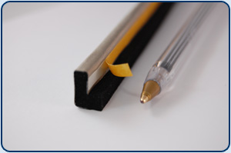
The gasket can be supplied in every size.
垫圈能以各种尺寸供应。
Please specify the size that you are looking.请指定你希望的尺寸
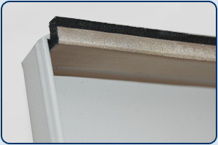
In the picture above you can see how the gasket is mounted on the inside of the lid. The gasket can be mounted with an adhesive or an conductive self adhesive.
在上面的图片里有能看到垫圈是如何装配在盖子的内侧的。垫圈的装配用一个黏合剂或导电黏合剂。
When the lid is closed the electrical contact is free of water and dust.
当盖子被闭合时电接触是不受水和尘土的影响的。

Benefits好处
- Bends easily around sharp corners without interrupting the water seal.
- 围绕锐角转角弯曲容易而没有中断水封。
- Excellent water sealing up to IP65 (depending on construction).卓越的水封可达IP65（依据材料）。
- Easy mounted with a self-adhesive strip.用一个自粘条很容易进行装配。
- Easy to use with small doors and lids. 小门和盖子很容易使用。
- Low closure force to prefent bending of doors and lids。低的闭合力
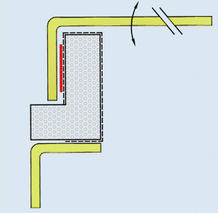
Options选件
- Custom made in the dimensions which you need 定制你需要的尺寸。
- Available in flame retardent version 可获得阻燃版。
- Available with conductive self afhesive 可获得带有导电自粘的。
- Available with chemical resistant rubbers like EPDM 可获得耐化学橡胶，如EPDM三元乙丙橡胶。
- Silicone sponge for high temperatures up to 220°C。 硅树脂海绵用于高温可达220°C
- Different conductive foils and fabrics against tension corrosion。不同的导电箔和植物抗拉力腐蚀。

Standard dimensions标准尺寸
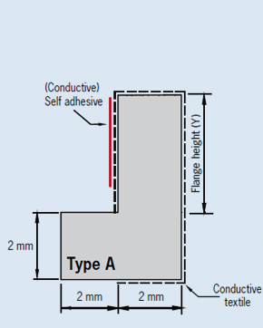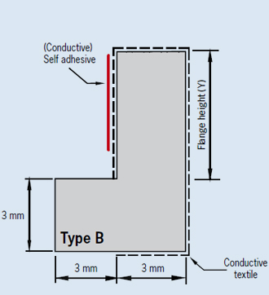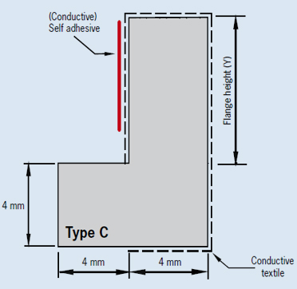

Flange height Y轮缘高度 | Type A | Type B | Type C
(mm) | Small小 | Medium中 | Large大
3 | 7503-S
4 | 7504-S | 7504-M
6 | 7506-S | 7506-M
8 | 7508-S | 7508-M | 7508-L
10 | 7510-S | 7510-M | 7510-L
12 | 7512-S | 7512-M | 7512-L
14 | 7514-S | 7514-M | 7514-L
16 | 7516-s |  | 7516-L
18 | 7518-s |  | 7518-L
20 | 7520-s |  | 7520-L

Shielding performance屏蔽性能
Shielding Performance屏蔽性能
Frequency Hz频率 | Mode | Screening in dB屏蔽
1 Mhz | E | 121 dB
10 Mhz | E | 110 dB
100 Mhz | E | 103 dB
400 Mhz | E | 98 dB
1 Ghz | P | 93 dB
10 Ghz | P | 90 dB

Example举例
When you order L-shape gasket 7500, medium 6 mm flange, with conductive textile (T)
当你订购L型垫圈7500时，中等的6mm凸缘，带有导电织物（T）。

Part number零件号 | Flange height (mm)凸缘高度 | Cover覆盖
7500 | 6 | T
 | Specify the flange height in mm  用mm单位指定凸缘高度 | T : Conductive textile导电织物  A : Amucor foil箔

