Honeycomb Fan Shield蜂窝风扇屏蔽
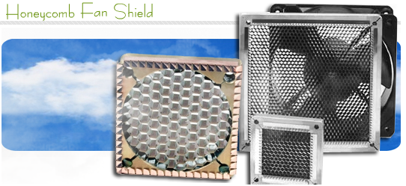

  Honeycomb Fan Shield蜂窝风扇屏蔽  Honeycomb vents & Filters蜂窝通风孔&滤波器  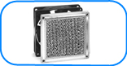  The Honeycomb Fan Shield Series are designed to provide EMI shielding and maximum air flow without degrading the fan output.  蜂窝风扇屏蔽系列设计用于提供EMI屏蔽和最大的空气流动没有降低风扇的输出。  These vents provide a low cost option to perforated metal when airflow rates are critical.  这些通风孔提供了一个低成本的选择，对于穿孔金属板当空气流量在临界时。  We stocks Honeycomb Fan Shield in 5 sizes corresponding to industry standard fans with standard 4-hole mounting. See table for the standard sizes.  我们现货的蜂窝风扇屏蔽有5个尺寸符合工业标准风扇带有4个孔装配。看表中给出的标准尺寸。  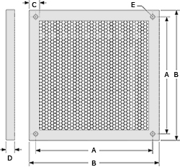  Shielding performance is achieved from 1/8 cell aluminum honeycomb panels mounted in high strength extruded aluminum frames with a beryllium copper fingerstrips for shielding the frame to the enclosure or an amucor shield.  屏蔽性能的实现是从1/8个单元铝制蜂窝板装配在高强度挤出成型铝制机框里带有一个铍铜指形簧片用于屏蔽机框到机壳或是一个amucor屏蔽。  Possible gasket solutions合适的垫圈解决  See here for gasket materials  Shielding Performance屏蔽性能  Honeycomb Fan Shield蜂窝风扇屏蔽  Performance have been measured with honeycomb specifiecations 1/8 Cell size, 1/4 Thick.性能的测量用蜂窝规格1/8单元尺寸，1/4厚度。  Dust screen防尘网  Dust screens consisting of multilayer expanded aluminum can be added, but airflow will be restricted.防尘网由多层延伸的铝的添加组成，但空气流动将被限制。 | With or Without dust filter  Technical picture of Fan Shield without filter风扇屏蔽的技术图片没有滤波器  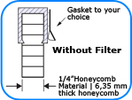  Technical picture of Fan Shield with filter风扇屏蔽的技术图片带有滤波器  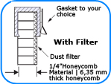
  Sequential Number For Frame Size用于机架尺寸的序列号
  # | Dimensions尺寸 |  |  | Order  Code订购码
  # | B | A | D | Order  Code订购码
  0  1  2  3  4  5 | 1.57"  2.36"  3.14"  4.69"  5.00"  3.62" | 1.26"  1.97"  2.81"  4.13"  4.45"  3.25" | .33"  .33"  .33"  .33"  .33"  .33" | 11  21  32  44  54  33
  Amucor Shield屏蔽   | BeCu Fingerstrip铍铜指形簧片  
  Honeycomb  Finish | E-Field电场 | Plane Wave平面波
  Honeycomb  Finish | 10MHz | 1 GHz | 10 GHz
  Iridite | 70 dB | 50 dB | 30 dB

