Honeycomb ventilation panels标准蜂窝通风板



  Standard Honeycomb ventilation panels标准蜂窝通风板  9500 serie系列  Shielded vent panels for ventilation and heating屏蔽的通风板用于通风设备和暖气设备  Honeycomb vents are used to shield openings for heating and ventilation against undesirable electromagnetic waves. 蜂窝通风使用屏蔽孔用于供暖与通风以防止不必要的电磁波。  The honeycomb vent panels are supplied in rigid aluminium frames, pre-drilled or with fasteners made to your specifications or flow drilled thread holes. 铝制蜂窝通风板的供应用刚性的铝制框架，预钻孔或用夹具做作你的规格或根据流程攻螺纹孔。  Standard and cross-cell version标准的和交叉单元版本  If a very high shielding level is required, the use of cross-cell honeycombs is recommended. These are made from two pieces of 6.35 mm or 12.7 mm thick honeycomb within a single frame. The shielding performance will improve at the expense of slightly increased air flow resistance. 如果要求一个非常高的屏蔽级别，推荐使用交叉单元蜂窝。这些由两件6.35mm或12.7mm厚的蜂窝在一个单个的框架内组成。在承担稍微的增加空气流动阻力的情况下屏蔽性能将得到提高。  The shielding effectiveness of the standard honeycomb ventilation panels is shown in the table below.标准的蜂窝通风板的屏蔽效能显示在下列的表里。  Shielding Performance屏蔽性能  In the table below some common types are specified to illustrate the required information. Hole diameter P is standard 3.5mm but it ca be delivered in any other size. Also available with screw apertures or inserts. 在下表里一些常用的类型的规格以给出插图需要的信息。孔直径P是标准的3.5mm，但它也能供应为任何其它的尺寸。也可获得以螺丝孔或镶嵌件。  Standard Dimensions标准尺寸  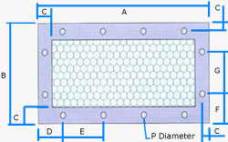  We provide Standard Honeycomb Ventilation products in all sizes.我们供应各种尺寸的标准蜂窝通风产品。  See pictures below for a Standard Honeycomb Ventilation panel in more than one meter by a meter.看下列图片，是一款标准蜂窝通风板，尺寸超过1米。  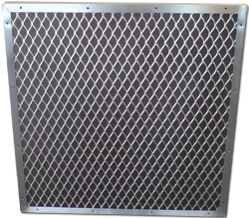  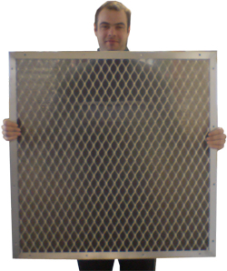 | Frame construction types...框架结构类型  We have 4 standard frame types. Zie pictures below.我们有4个标准框架类型。看下列图片。  Frame A框架  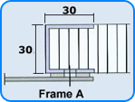  Frame B框架  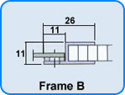  Frame C框架  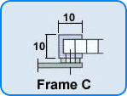  Frame D框架  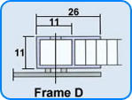  Frame E框架  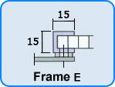  Honeycomb vent with round hole蜂窝通风板带有圆形孔  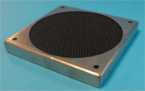  Almost every size from stock现存货里有各种的尺寸  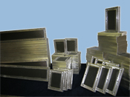  How to order如何订购  All honeycomb vents are made according to customers specifications, so ther are no standard part numbers. When ordering honeycomb vents, the following information should be provided: frame style, dimensions, quantity and gasket material.  所有的蜂窝通风板是根据客户的规格要求定制的，因此没有标准的零件号。当订购蜂窝通风板时需要提供下列信息：框架类型，尺寸，数量和垫圈材料。  The standard material for gaskets is an Endless gasket 8100 series, thickness 2-4 mm, depending on outer dimensions.  用于垫圈的标准材料是一个环形垫圈8100系列，厚度2-4 mm，依据外部尺寸。
  Frequency MHz频率 | Mode | Attenuation dB衰减
  0.01 | H-Field | 45
  0.1 | H-Field | 49
  1.0 | H-Field | 51
  1.0 | E-Field | >100
  10.0 | E-Field | >100
  100.0 | E-Field | >>100
  1000.0 | Plane Wave | 98
  10000.0 | Plane Wave | 95
  See Guarantee
  Outer dimension外部尺寸 |  | Mounting holes horizontal装配孔水平的 |  |  | Mounting holes vertical装配孔垂直的
  A | B | no | D | E | no | F | G
  150  100  200  125  250  150  300  175  350  200  400  250  300  600 | 75  100  100  125  125  150  150  175  175  200  200  250  300  300 | 2  1  3  2  3  2  4  2  4  3  5  3  4  7 | 40  50  20  20  30  25  30  40  40  20  30  30  30  30 | 70  -  80  85  95  100  80  95  90  80  85  95  80  90 | 1  1  1  1  1  2  2  2  2  3  3  3  4  4 | 37.5  50  50  62.5  62.5  25  25  40  40  20  20  30  30  30 | -  -  -  -  -  100  100  95  95  80  80  95  80  80

