Thin Shielding Filter薄的屏蔽滤波器
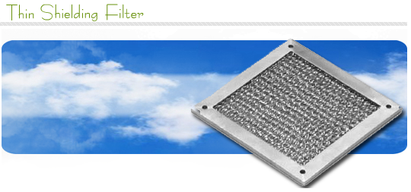
  Thin Shielding Filter薄的屏蔽滤波器  Composed of expanded multi-layer alluminum, Thin Screen Shields combine the functions of EMI shielding with efficient dust filtering and ventilation. Thinner than electronic filter dust shields, they provide better dust extraction, but with greater restriction of air flow. They cost less than electronic dust shields and honeycomb.  由多层的铝网组成，薄的帘栅屏蔽结合了EIM屏蔽带有有效的灰尘滤波和通风的功能。更薄于电子滤波器防尘罩，它们提供了更好的灰尘提取，但带有更大的气流限制。它们成本少于电子防尘罩和蜂窝通风板。  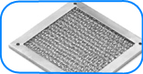  Special Notes特殊的备注  When ordering, please furnish a detailed drawing specifying all dimensions shown in Fig. 1 including size and location of mounting holes, and type of gasket required.  当订购时请提供一个详细的设计图纸指定所有的显示在图1上的尺寸。包括尺寸和装配孔的位置，需要的垫圈的位置。  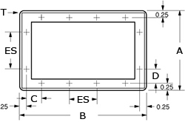 | "U" Channel Frame Styles  “U”形通道框架类型  Frame type框架类型  1.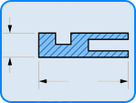  Frame type框架类型  2.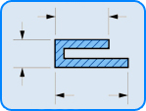  Frame type框架类型  3.