1100 Thermal grease热油脂

Thermal Grease 1100 serie系列热油脂

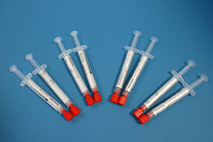
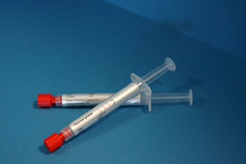
The Shielding Thermal Greases are ceramic-filled single component silicones with a high thermal conductivity. The non-cross linked thermal compounds do not dry out. The silicone components do not leak out of the compound. The silicone-free thermal compound 1100-12 consists of synthetic, thermal polymer and is suitable for a fast and effective heat dissipation. The paste is particularly suitable for silicone sensitive applications. The 1100’s long-term stability guarantees a full operability during the entire life time of the product. Under normal applications conditions Thermal Grease does not cure, dry our or melt. Special storage of Thermal Grease is not required, therefore they can be stored under normal climate conditions for up to 12 months. If any separation of the filler materials becomes evident, the 1100’s must be mixed thoroughly before use.
屏蔽热油脂是陶瓷增强型单成分硅树脂带有一个高的热导率。这个非交联的热复合物不需变干。该硅树脂成分不从复合物里漏出。不含硅树脂的热复合物1100-12由合成纤维、热聚合物组成，和适合于一个快速和有效的热耗散。该糊剂是特别适合于硅树脂敏感的应用。该1100的长期稳定性确保在产品的整个生命周期期间有一个完全的可操作性。在通常的应用条件下，热油脂不凝固，干燥或融化。热油脂没有特别储存的需要。因此它们能被储存在常规的大气条件下，可达12个月。如果填充材料的任何分离已变的很明显，1100在使用前必须被彻底的混合。

Comparision of the thermal resistance 0,02 比较的热电阻
(In relation with the contact pressure与接触压力有关)


Partnumber零件号 1100-96 | Partnumber零件号 1100-98
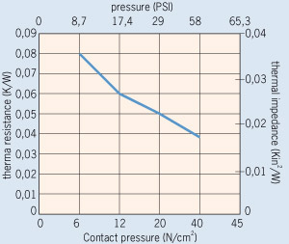 | 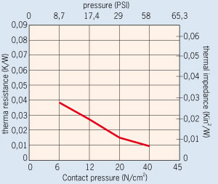
Partnumber零件号 1100-97 | Partnumber零件号 1100-12
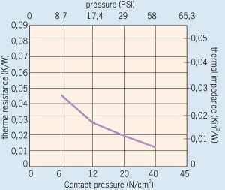 | 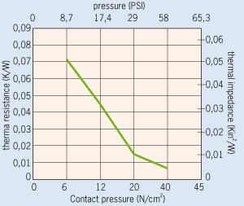

1100-92 and 1100-97 are ceramic-filled single-component silicones with a high thermal conductivity. The noncrosslinked thermal compounds do not dry out. The silicone components do not leak out of the compound.
1100-92和1100-97是陶瓷增强型单成分硅树脂带有一个高的热导率。这个非交联的热复合物不用变干。硅树脂成分不从复合物里渗出。

Silicone free version不含硅树脂版
The silicone-free thermal compound 1100-12 consists of synthetic, thermal polymer and is suitable for a fast and effective heat dissipation. The paste is particularly suitable for silicone sensitive applications. Its long-term stability guarantees a full operability during the entire life time of the product. Under normal application conditions the 1100-12 silicone-free does not cure, dry out or melt.
不含硅树脂热复合物1100-12由合成纤维、热聚合物组成，适合于做一个快而有效的热耗散。该糊剂是特别适合于硅树脂敏感应用。它的长期稳定性在产品的总寿命期间确保了一个完全的可操作性。在常规的应用状态下，1100-12不含硅树脂不固化、变干或融化。

Storage存储
Special storage of the “Thermal Grease” is not required, therefore they can be stored under normal climate conditions for up to 12 months. If any separation of the filler materials becomes evident, the 1100 serie must be mixed thoroughly before use.
“热油脂”的特殊的存储是不需要的。因此，它们能被存储在常规的大气条件下直到12个月。如果填充料的任何分离变的明显，该1100系列必须在使用前进行彻底的混合。

Thermal resistance in relation to contact pressure热阻与接触压力有关
Contact pressure接触压力 (N/cm²) | Thermal resistance热阻 (K/W)
 | 1100-12 | 1100-96 | 1100-97 | 1100-98
10 | 0.055 | 0.065 | 0.032 | 0.035
15 | 0.040 | 0.055 | 0.023 | 0.020
20 | 0.015 | 0.050 | 0.019 | 0.015
25 | 0.008 | 0.048 | 0.018 | 0.014
30 | 0.007 | 0.045 | 0.015 | 0.013
35 | 0.006 | 0.042 | 0.013 | 0.011
40 | 0.005 | 0.038 | 0.012 | 0.010

Properties per partnumber每个零件号的特性
Properties特性 | Unit | 1100-96. | 1100-97 | 1100-98 | 1100-12
Colour颜色 |  | Dark white暗白 | White白 | Grey灰 | Silver银
Compound复合物 |  | Soft软 / pasty
Thermal properties热特性
Thermal resistance Rth热阻 | K/W | 0.038 | 0.012 | 0.01 | 0.006
Thermal impedance热阻抗 | °Cmm²/W  KIN²/W | 11  0.0017 | 4,5  0.007 | 4,1  0.0064 | 2,2  0.0033
Thermal conductivity导热性 | W/mK | 2.4 | 5.0 | 6.0 | 10.0
Electrical properties电特性
Dielectric breakdown介质击穿 Ed; ac | kV/mm | Conductive导电性
Mechanical properties机械特性
Measured thickness测量厚度 (+/- 10%) | mm | 0.035 | 0.025 | 0.025 | 0.025
Viscosity黏度 | Pas | 25 - 35 | 90 - 120 | 110 - 130 | 60 - 90
Density密度 | g/cm³ | 2.6 | 2.1 | 2.2 | 1.4
Application temperature应用温度 | °C | -60 to +150
TML | Ma. % | < 1.4 | < 1.3 | < 1.5 | < 1.1
Long term stability长期稳定性 (1000 h / 85°C / 85% relative humidity相对湿度)
Thermal resistance Rth热阻 | K/W | 0.038 | 0.012 | 0.008 | 0.006

Example举例
When you want to order Thermal grease please specify the following。当你想订购热油脂时，请指定下列信息：

Serie系列 | Type类型 | Ml毫升 | Quantity数量
1100 | 12 | 75 | 10
 | 96 : Dark white暗白  97 : White白  98 : Grey灰  12 : Silver银 | Standard package标准包装75 ml, Other on request其它的根据需求。

