SAS-521F-7 Bi-Logical Antenna Data
1 Meter | 3 Meter | 10 Meter
Antenna Page | VSWR Graph | AF Graph

- Typical Antenna Factor Plot
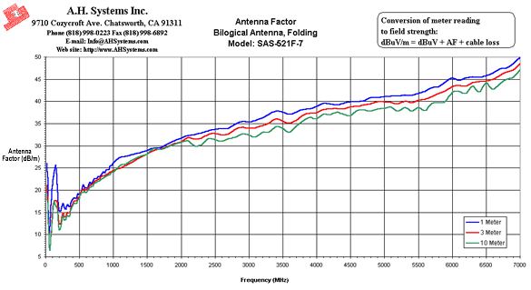
- Typical VSWR
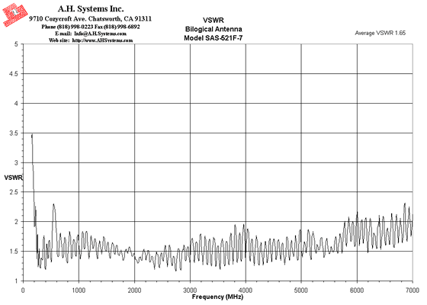
- Mounting Diagram for the bilogical antenna series
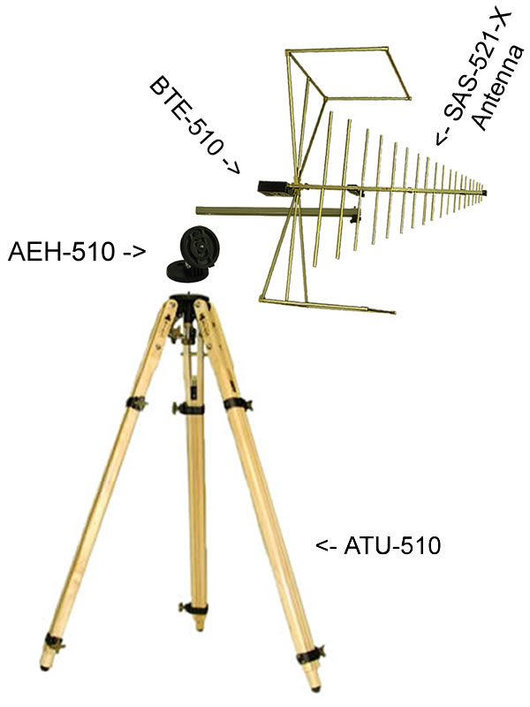

SAS-521F-7 Bi-Logical Antenna Data
1 Meter | 3 Meter | 10 Meter
Antenna Page | VSWR Graph | AF Graph

1 Meter Antenna Factor
Frequency (MHz) | AF (dB/m) | Gain (dBi) | Gain (Numeric)
25 | 26.0 | -27.8 | 0.00
30 | 23.5 | -23.7 | 0.00
35 | 21.5 | -20.4 | 0.01
40 | 16.8 | -14.5 | 0.04
45 | 14.4 | -11.1 | 0.08
50 | 9.5 | -5.3 | 0.29
60 | 11.3 | -5.5 | 0.28
70 | 12.4 | -5.3 | 0.30
80 | 15.1 | -6.7 | 0.21
90 | 19.3 | -10.0 | 0.10
100 | 20.8 | -10.6 | 0.09
125 | 23.4 | -11.2 | 0.08
150 | 25.5 | -11.8 | 0.07
175 | 20.3 | -5.2 | 0.30
200 | 15.5 | 0.8 | 1.21
225 | 15.2 | 2.1 | 1.62
250 | 16.9 | 1.3 | 1.34
275 | 16.2 | 2.8 | 1.91
300 | 15.6 | 4.2 | 2.61
325 | 16.7 | 3.8 | 2.41
350 | 16.2 | 4.9 | 3.11
375 | 17.2 | 4.5 | 2.84
400 | 17.9 | 4.3 | 2.72
425 | 18.2 | 4.6 | 2.87
450 | 18.1 | 5.2 | 3.29
475 | 19.1 | 4.6 | 2.91
500 | 18.9 | 5.3 | 3.38
525 | 19.0 | 5.6 | 3.66
550 | 21.2 | 3.9 | 2.45
575 | 20.7 | 4.7 | 2.96
600 | 20.4 | 5.4 | 3.44
625 | 20.6 | 5.6 | 3.63
650 | 21.7 | 4.8 | 3.02
675 | 21.5 | 5.4 | 3.45
700 | 21.9 | 5.3 | 3.38
725 | 22.5 | 4.9 | 3.11
750 | 22.6 | 5.2 | 3.30
775 | 23.0 | 5.0 | 3.17
800 | 22.9 | 5.4 | 3.45
825 | 23.4 | 5.1 | 3.27
850 | 24.1 | 4.7 | 2.95
875 | 23.9 | 5.2 | 3.30
900 | 24.6 | 4.8 | 2.99
925 | 24.5 | 5.0 | 3.18
950 | 25.4 | 4.4 | 2.74
975 | 25.5 | 4.5 | 2.81
1000 | 26.1 | 4.2 | 2.62
1100 | 27.3 | 3.7 | 2.37
1200 | 27.6 | 4.2 | 2.62
1300 | 28.1 | 4.4 | 2.77
1400 | 28.5 | 4.7 | 2.94
1500 | 28.9 | 4.8 | 3.04
1600 | 29.5 | 4.8 | 3.05
1700 | 29.6 | 5.2 | 3.34
1800 | 30.4 | 5.0 | 3.14
1900 | 31.2 | 4.6 | 2.92
2000 | 31.7 | 4.6 | 2.89
2100 | 32.3 | 4.3 | 2.72
2200 | 32.5 | 4.6 | 2.88
2300 | 32.9 | 4.6 | 2.87
2400 | 33.4 | 4.5 | 2.79
2500 | 33.7 | 4.5 | 2.81
2600 | 33.8 | 4.7 | 2.96
2700 | 33.9 | 4.9 | 3.12
2800 | 34.9 | 4.3 | 2.70
2900 | 35.5 | 4.0 | 2.51
3000 | 35.3 | 4.4 | 2.78
3100 | 35.7 | 4.3 | 2.72
3200 | 36.3 | 4.1 | 2.54
3300 | 37.1 | 3.5 | 2.24
3400 | 37.8 | 3.1 | 2.03
3500 | 37.5 | 3.6 | 2.29
3600 | 37.1 | 4.3 | 2.67
3700 | 37.6 | 4.0 | 2.50
3800 | 38.2 | 3.6 | 2.32
3900 | 38.3 | 3.8 | 2.37
4000 | 38.9 | 3.4 | 2.20
4100 | 39.6 | 2.9 | 1.97
4200 | 39.4 | 3.3 | 2.12
4300 | 39.2 | 3.7 | 2.37
4400 | 39.6 | 3.6 | 2.27
4500 | 39.9 | 3.4 | 2.19
4600 | 39.9 | 3.6 | 2.30
4700 | 40.2 | 3.5 | 2.25
4800 | 40.8 | 3.1 | 2.02
4900 | 40.9 | 3.2 | 2.08
5000 | 41.1 | 3.1 | 2.04
5100 | 41.2 | 3.2 | 2.09
5200 | 41.2 | 3.4 | 2.19
5300 | 41.4 | 3.3 | 2.15
5400 | 41.4 | 3.5 | 2.26
5500 | 41.8 | 3.3 | 2.12
5600 | 42.3 | 2.9 | 1.95
5700 | 43.1 | 2.3 | 1.70
5800 | 43.3 | 2.2 | 1.68
5900 | 44.3 | 1.3 | 1.36
6000 | 45.3 | 0.5 | 1.13
6100 | 44.8 | 1.2 | 1.31
6200 | 45.4 | 0.7 | 1.19
6300 | 45.5 | 0.7 | 1.18
6400 | 45.4 | 1.0 | 1.25
6500 | 45.8 | 0.7 | 1.18
6600 | 46.3 | 0.3 | 1.07
6700 | 47.3 | -0.5 | 0.89
6800 | 47.6 | -0.7 | 0.86
6900 | 48.5 | -1.4 | 0.72
7000 | 49.8 | -2.7 | 0.54

3 Meter Antenna Factor
Frequency (MHz) | AF (dB/m) | Gain (dBi) | Gain (Numeric)
25 | 21.1 | -22.9 | 0.01
30 | 18.4 | -18.6 | 0.01
35 | 18.4 | -17.3 | 0.02
40 | 13.2 | -10.9 | 0.08
45 | 13.2 | -9.9 | 0.10
50 | 9.1 | -4.9 | 0.32
60 | 7.0 | -1.2 | 0.75
70 | 6.8 | 0.3 | 1.07
80 | 8.5 | -0.2 | 0.95
90 | 11.6 | -2.3 | 0.59
100 | 14.3 | -4.0 | 0.39
125 | 17.4 | -5.2 | 0.30
150 | 17.6 | -3.9 | 0.41
175 | 17.1 | -1.9 | 0.64
200 | 12.5 | 3.8 | 2.39
225 | 12.2 | 5.1 | 3.22
250 | 14.8 | 3.4 | 2.19
275 | 14.1 | 5.0 | 3.14
300 | 14.1 | 5.7 | 3.72
325 | 15.0 | 5.5 | 3.58
350 | 14.8 | 6.3 | 4.29
375 | 16.0 | 5.7 | 3.72
400 | 16.7 | 5.5 | 3.59
425 | 17.5 | 5.3 | 3.39
450 | 17.6 | 5.8 | 3.76
475 | 18.2 | 5.6 | 3.61
500 | 18.4 | 5.8 | 3.81
525 | 19.6 | 5.1 | 3.22
550 | 20.1 | 5.0 | 3.13
575 | 20.3 | 5.1 | 3.25
600 | 19.9 | 5.9 | 3.86
625 | 20.3 | 5.8 | 3.83
650 | 21.1 | 5.4 | 3.50
675 | 21.2 | 5.6 | 3.65
700 | 21.4 | 5.8 | 3.78
725 | 21.9 | 5.6 | 3.63
750 | 22.2 | 5.5 | 3.58
775 | 22.4 | 5.6 | 3.66
800 | 22.6 | 5.7 | 3.73
825 | 23.1 | 5.5 | 3.57
850 | 23.1 | 5.7 | 3.73
875 | 23.3 | 5.8 | 3.78
900 | 23.5 | 5.9 | 3.85
925 | 23.8 | 5.8 | 3.77
950 | 24.1 | 5.7 | 3.73
975 | 24.1 | 5.9 | 3.91
1000 | 24.4 | 5.8 | 3.84
1100 | 24.9 | 6.2 | 4.14
1200 | 25.6 | 6.2 | 4.18
1300 | 26.4 | 6.1 | 4.08
1400 | 27.4 | 5.8 | 3.77
1500 | 28.1 | 5.7 | 3.72
1600 | 29.0 | 5.4 | 3.45
1700 | 29.3 | 5.6 | 3.62
1800 | 29.8 | 5.6 | 3.60
1900 | 30.5 | 5.3 | 3.41
2000 | 30.9 | 5.3 | 3.41
2100 | 31.8 | 4.9 | 3.09
2200 | 31.4 | 5.7 | 3.67
2300 | 31.7 | 5.7 | 3.75
2400 | 32.5 | 5.4 | 3.43
2500 | 32.7 | 5.5 | 3.53
2600 | 32.4 | 6.1 | 4.07
2700 | 32.7 | 6.2 | 4.15
2800 | 33.7 | 5.5 | 3.55
2900 | 34.1 | 5.4 | 3.44
3000 | 33.9 | 5.9 | 3.89
3100 | 34.0 | 6.0 | 4.02
3200 | 34.6 | 5.8 | 3.80
3300 | 35.1 | 5.5 | 3.58
3400 | 36.1 | 4.8 | 3.04
3500 | 35.6 | 5.5 | 3.59
3600 | 35.1 | 6.3 | 4.23
3700 | 35.7 | 5.9 | 3.91
3800 | 36.9 | 5.0 | 3.14
3900 | 37.3 | 4.7 | 2.98
4000 | 37.5 | 4.8 | 3.01
4100 | 38.1 | 4.4 | 2.74
4200 | 38.3 | 4.4 | 2.77
4300 | 38.4 | 4.6 | 2.86
4400 | 38.3 | 4.8 | 3.01
4500 | 38.8 | 4.6 | 2.85
4600 | 38.9 | 4.6 | 2.89
4700 | 39.2 | 4.5 | 2.83
4800 | 39.4 | 4.5 | 2.79
4900 | 39.9 | 4.2 | 2.61
5000 | 40.0 | 4.3 | 2.68
5100 | 39.8 | 4.6 | 2.85
5200 | 39.5 | 5.1 | 3.24
5300 | 40.1 | 4.7 | 2.93
5400 | 39.6 | 5.3 | 3.36
5500 | 40.3 | 4.8 | 2.99
5600 | 40.5 | 4.7 | 2.95
5700 | 41.1 | 4.3 | 2.69
5800 | 41.8 | 3.7 | 2.34
5900 | 42.4 | 3.2 | 2.10
6000 | 43.3 | 2.5 | 1.77
6100 | 43.6 | 2.4 | 1.72
6200 | 43.4 | 2.7 | 1.85
6300 | 44.2 | 2.0 | 1.58
6400 | 44.5 | 1.9 | 1.55
6500 | 44.6 | 1.9 | 1.56
6600 | 45.0 | 1.7 | 1.47
6700 | 45.8 | 1.0 | 1.26
6800 | 46.6 | 0.3 | 1.08
6900 | 47.0 | 0.0 | 0.99
7000 | 48.5 | -1.3 | 0.73

10 Meter Antenna Factor
Frequency (MHz) | AF (dB/m) | Gain (dBi) | Gain (Numeric)
25 | 19.2 | -21.0 | 0.01
30 | 17.2 | -17.4 | 0.02
35 | 17.2 | -16.0 | 0.02
40 | 12.4 | -10.1 | 0.10
45 | 12.4 | -9.1 | 0.12
50 | 8.9 | -4.6 | 0.34
60 | 6.4 | -0.6 | 0.88
70 | 6.6 | 0.5 | 1.12
80 | 8.5 | -0.2 | 0.96
90 | 12.1 | -2.7 | 0.53
100 | 13.0 | -2.8 | 0.53
125 | 17.3 | -5.2 | 0.31
150 | 16.2 | -2.5 | 0.57
175 | 15.9 | -0.8 | 0.83
200 | 11.1 | 5.2 | 3.31
225 | 11.3 | 6.0 | 3.98
250 | 14.2 | 4.0 | 2.49
275 | 13.2 | 5.8 | 3.80
300 | 13.4 | 6.4 | 4.34
325 | 14.3 | 6.2 | 4.17
350 | 14.0 | 7.1 | 5.17
375 | 15.6 | 6.1 | 4.09
400 | 16.4 | 5.9 | 3.91
425 | 17.1 | 5.7 | 3.71
450 | 16.9 | 6.4 | 4.34
475 | 17.8 | 6.0 | 4.01
500 | 18.2 | 6.0 | 4.03
525 | 19.3 | 5.4 | 3.46
550 | 19.4 | 5.7 | 3.68
575 | 19.8 | 5.7 | 3.70
600 | 19.4 | 6.4 | 4.33
625 | 19.8 | 6.3 | 4.30
650 | 20.6 | 5.9 | 3.93
675 | 20.8 | 6.0 | 4.00
700 | 20.9 | 6.3 | 4.25
725 | 21.5 | 6.0 | 3.96
750 | 21.8 | 6.0 | 3.96
775 | 22.0 | 6.0 | 4.00
800 | 22.1 | 6.2 | 4.13
825 | 22.5 | 6.1 | 4.06
850 | 22.7 | 6.2 | 4.13
875 | 22.9 | 6.2 | 4.15
900 | 23.1 | 6.2 | 4.19
925 | 23.4 | 6.2 | 4.13
950 | 23.5 | 6.3 | 4.25
975 | 23.9 | 6.1 | 4.06
1000 | 23.9 | 6.3 | 4.27
1100 | 25.5 | 5.6 | 3.62
1200 | 26.0 | 5.8 | 3.82
1300 | 26.9 | 5.6 | 3.66
1400 | 27.6 | 5.5 | 3.58
1500 | 28.1 | 5.6 | 3.66
1600 | 29.4 | 4.9 | 3.11
1700 | 29.2 | 5.7 | 3.69
1800 | 29.8 | 5.6 | 3.61
1900 | 30.3 | 5.5 | 3.54
2000 | 30.8 | 5.5 | 3.55
2100 | 31.1 | 5.6 | 3.59
2200 | 30.0 | 7.1 | 5.16
2300 | 30.1 | 7.3 | 5.42
2400 | 31.6 | 6.3 | 4.26
2500 | 31.4 | 6.8 | 4.81
2600 | 31.0 | 7.5 | 5.67
2700 | 31.6 | 7.2 | 5.29
2800 | 32.0 | 7.2 | 5.26
2900 | 32.6 | 6.8 | 4.84
3000 | 32.5 | 7.3 | 5.39
3100 | 32.0 | 8.1 | 6.47
3200 | 33.0 | 7.4 | 5.48
3300 | 33.1 | 7.5 | 5.63
3400 | 34.3 | 6.5 | 4.50
3500 | 33.9 | 7.2 | 5.29
3600 | 33.0 | 8.3 | 6.82
3700 | 34.5 | 7.2 | 5.20
3800 | 35.6 | 6.2 | 4.21
3900 | 36.4 | 5.6 | 3.66
4000 | 36.1 | 6.2 | 4.16
4100 | 37.2 | 5.3 | 3.42
4200 | 37.0 | 5.7 | 3.72
4300 | 37.6 | 5.4 | 3.44
4400 | 37.1 | 6.0 | 3.98
4500 | 36.8 | 6.5 | 4.50
4600 | 38.0 | 5.5 | 3.57
4700 | 38.0 | 5.7 | 3.71
4800 | 37.8 | 6.0 | 4.03
4900 | 38.3 | 5.8 | 3.76
5000 | 38.4 | 5.9 | 3.86
5100 | 38.8 | 5.6 | 3.62
5200 | 37.8 | 6.8 | 4.77
5300 | 38.6 | 6.1 | 4.12
5400 | 37.8 | 7.1 | 5.08
5500 | 38.6 | 6.4 | 4.38
5600 | 37.9 | 7.3 | 5.41
5700 | 39.6 | 5.8 | 3.80
5800 | 39.7 | 5.8 | 3.78
5900 | 40.0 | 5.7 | 3.68
6000 | 42.1 | 3.7 | 2.36
6100 | 42.3 | 3.7 | 2.34
6200 | 41.8 | 4.3 | 2.70
6300 | 43.4 | 2.8 | 1.91
6400 | 42.1 | 4.2 | 2.65
6500 | 44.1 | 2.4 | 1.72
6600 | 42.7 | 3.9 | 2.45
6700 | 43.9 | 2.8 | 1.93
6800 | 45.0 | 1.9 | 1.56
6900 | 45.5 | 1.6 | 1.43
7000 | 47.1 | 0.0 | 1.01

