BCP-511 Broadband Current Probe Data宽带电流探头数据

- Numeric Data
Transfer Impedance Factor Model: BCP-511
Frequency | Transfer Impedance Factor (dB ohms)
20 KHz | -11.03
30 KHz | -7.97
40 KHz | -6.1
50 KHz | -4.84
60 KHz | -3.87
70 KHz | -3.24
80 KHz | -2.76
90 KHz | -2.37
100 KHz | -2.24
200 KHz | -1.1
500 KHz | -0.6
1 MHz | -0.44
2 MHz | -0.33
5 MHz | -0.26
10 MHz | -0.2
20 MHz | -0.04
50 MHz | -0.47
100 MHz | -0.33
Conversion Formulas: dBuA = dBuV - dB ohms + Cable Loss
- Transfer Impedance Graph
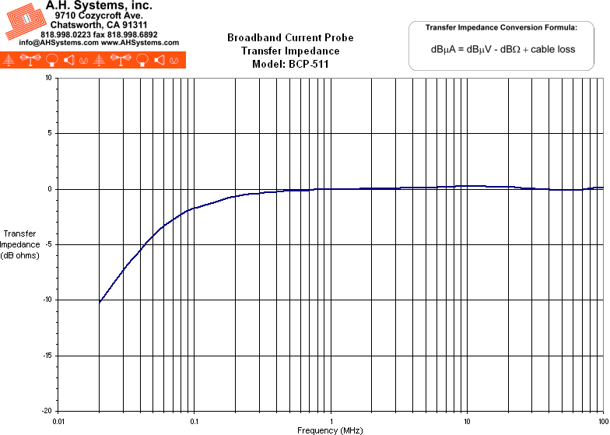
- Product Datasheet (290Kb)
- Operation Manual (198Kb)

