BCP-510 Broadband Current Probe Data宽带电流探头数据

- Numeric Data
Transfer Impedance Factor
Model: BCP-510

Frequency | Transfer Impedance Factor (dB ohms)
20 Hz | -55.55
30 Hz | -51.89
40 Hz | -49.80
50 Hz | -47.86
60 Hz | -46.67
70 Hz | -45.28
80 Hz | -44.03
90 Hz | -43.08
100 Hz | -42.25
120 Hz | -40.67
140 Hz | -38.92
160 Hz | -38.89
180 Hz | -37.67
200 Hz | -36.80
250 Hz | -35.64
300 Hz | -34.80
350 Hz | -33.97
400 Hz | -33.50
450 Hz | -32.97
500 Hz | -32.47
1 KHz | -30.92
2 KHz | -30.47
5 KHz | -30.01
10 KHz | -29.88
20 KHz | -29.97
50 KHz | -29.94
100 KHz | -29.78
200 KHz | -29.78
500 KHz | -29.83
1 MHz | -29.92

Conversion Formulas: dBuA = dBuV - dB ohms + Cable Loss

- Transfer Impedance Graph
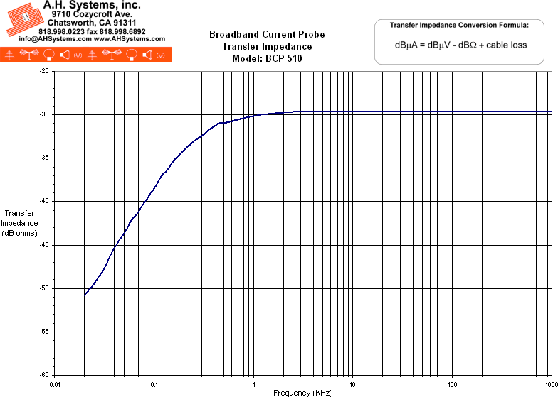
- Product Datasheet (298Kb)
- Operation Manual (198Kb)

