BCP-512 Broadband Current Probe Data 宽带电流探头数据

- Numeric Data
Transfer Impedance Factor Model: BCP-512
Frequency | Transfer Impedance (dB ohms)
1 MHz | 0.0
2 MHz | 4.3
3 MHz | 6.5
4 MHz | 7.8
5 MHz | 8.7
6 MHz | 9.5
7 MHz | 10.2
8 MHz | 10.7
9 MHz | 11.2
10 MHz | 11.7
20 MHz | 14.4
30 MHz | 16.2
40 MHz | 17.0
50 MHz | 17.5
60 MHz | 18.2
70 MHz | 18.9
80 MHz | 19.4
90 MHz | 19.7
100 MHz | 19.8
200 MHz | 21.5
300 MHz | 22.1
400 MHz | 22.2
500 MHz | 22.4
600 MHz | 22.5
700 MHz | 22.8
800 MHz | 22.9
900 MHz | 23.4
1000 MHz | 23.3
Conversion Formulas: dBuA = dBuV - dB ohms + Cable Loss

- Transfer Impedance Graph
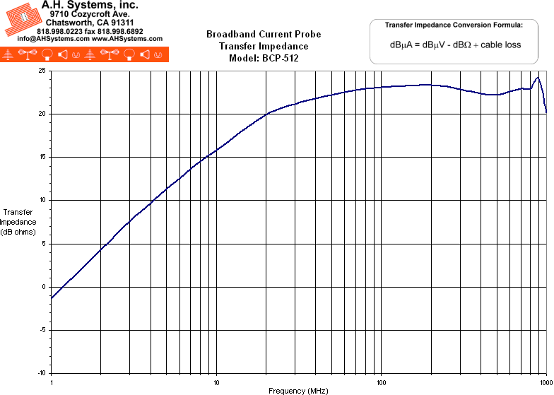
- Product Datasheet (272Kb)
- Operation Manual (198Kb)

