BCP-514 More Information

- Numeric Data
Transfer Impedance Factor Model: BCP-514
Frequency | Transfer Impedance (dB ohms)
10 KHz | -17.76
20 KHz | -12.04
30 KHz | -8.94
40 KHz | -6.90
50 KHz | -5.56
60 KHz | -4.67
70 KHz | -3.97
80 KHz | -3.46
90 KHz | -3.07
100 KHz | -2.93
200 KHz | -1.53
300 KHz | -1.20
400 KHz | -1.04
500 KHz | -0.93
600 KHz | -0.83
700 KHz | -0.80
800 KHz | -0.76
900 KHz | -0.70
1 MHz | -0.67
2 MHz | -0.56
5 MHz | -0.43
10 MHz | -0.33
20 MHz | -0.40
50 MHz | -0.63
100 MHz | -0.37
Conversion Formulas: dBuA = dBuV - dB ohms + Cable Loss

- Transfer Impedance Graph
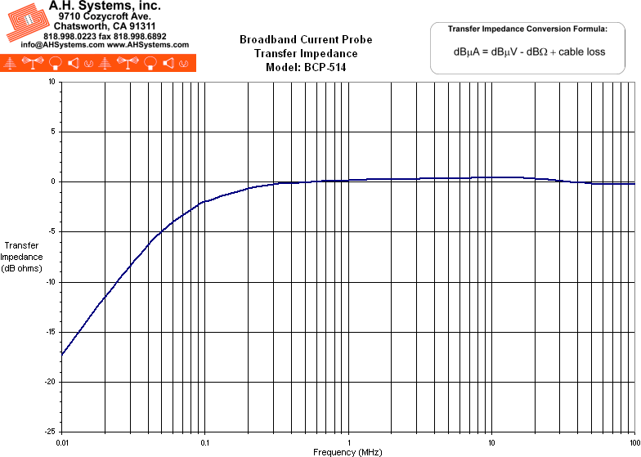
- Product Datasheet (294Kb)
- Operation Manual (198Kb)

