BCP-518 Broadband Current Probe Data宽带电流探头数据
- Numeric Data
Transfer Impedance Factor Model: BCP-518
Frequency | Transfer Impedance Factor (dB ohms)
100 KHz | -9.2
120 KHz | -7.7
140 KHz | -6.5
160 KHz | -5.5
180 KHz | -4.6
200 KHz | -3.8
250 KHz | -2.3
300 KHz | -1.0
350 KHz | 0.0
400 KHz | 0.8
450 KHz | 1.5
500 KHz | 2.1
600 KHz | 3.1
700 KHz | 3.9
800 KHz | 4.6
900 KHz | 5.1
1.0 MHz | 5.6
1.5 MHz | 7.2
2 MHz | 8.3
3 MHz | 9.6
4 MHz | 10.5
5 MHz | 11.2
7 MHz | 12.0
10 MHz | 12.9
20 MHz | 13.2
50 MHz | 13.5
70 MHz | 13.5
100 MHz | 14.1
200 MHz | 14.2
300 MHz | 14.2
400 MHz | 13.5
500 MHz | 12.1
Conversion Formulas: dBuA = dBuV - dB ohms + Cable Loss
- Transfer Impedance Graph
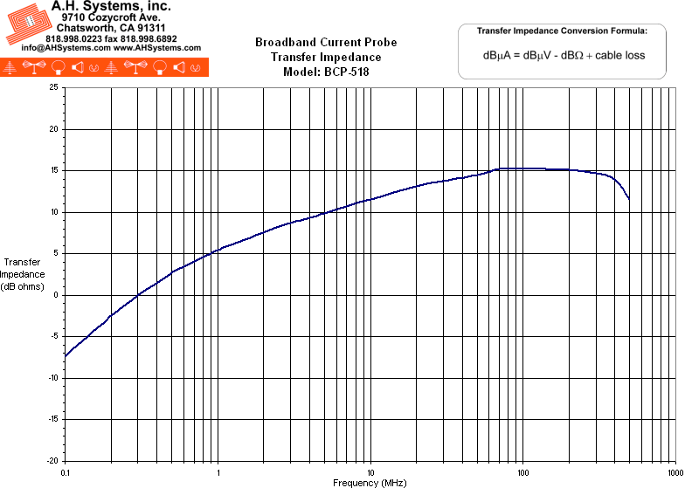
- Operation Manual (198Kb)

