BCP-519 Broadband Current Probe Data宽带电流探头数据

- Transfer Impedance Graph
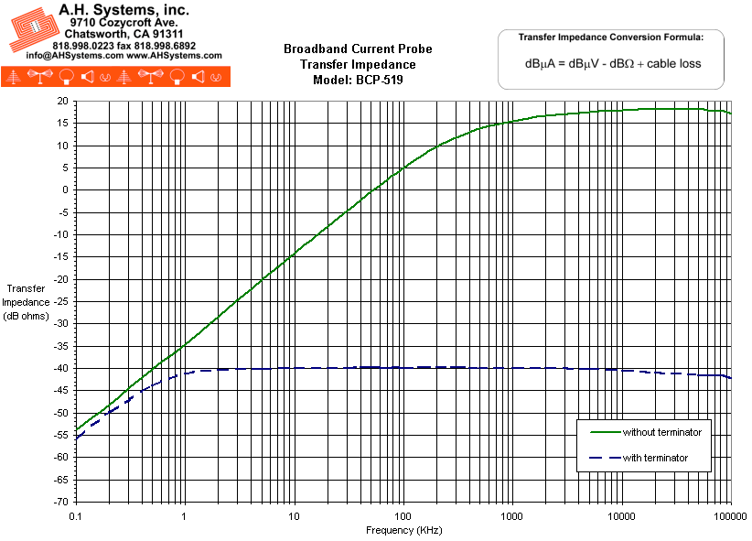
- Operation Manual (198Kb)

