BCP-522 Broadband Current Probe Data宽带电流探头数据

- Numeric Data
Transfer Impedance Factor Model: BCP-522
Frequency | Transfer Impedance Factor (dB ohms)
1 KHz | -31.1
2 KHz | -25.0
5 KHz | -17.3
10 KHz | -11.8
20 KHz | -6.8
30 KHz | -4.7
40 KHz | -3.6
50 KHz | -3.0
60 KHz | -2.6
70 KHz | -2.3
80 KHz | -2.1
90 KHz | -2.0
100 KHz | -1.9
200 KHz | -1.5
500 KHz | -0.8
1 MHz | -0.7
2 MHz | -0.7
5 MHz | -0.5
10 MHz | -0.4
20 MHz | -0.4
30 MHz | -0.4
40 MHz | -0.4
50 MHz | -0.7
100 MHz | -0.6
150 MHz | -0.3
200 MHz | -0.2
Conversion Formulas: dBuA = dBuV - dB ohms + Cable Loss

- Transfer Impedance Graph
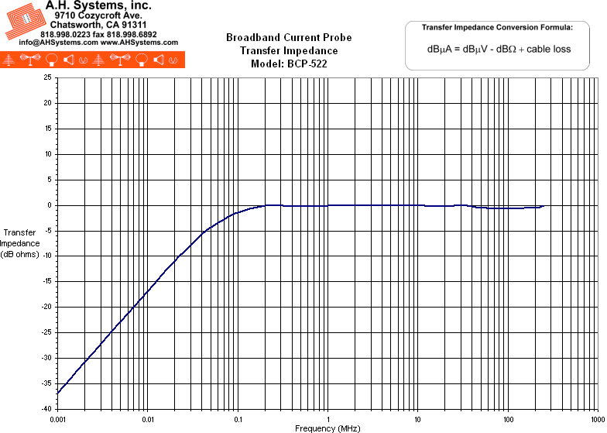
- Operation Manual (198Kb)

