FCC-2 Tuned Dipole Antenna Data

More Information
- Typical Antenna Factor Plot - 3m
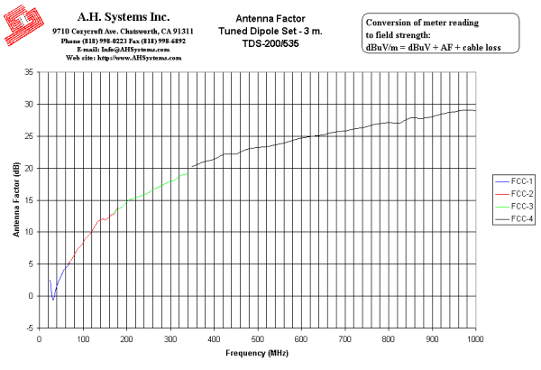
Innovation, Quality, and Performance
- Typical Antenna Factor Plot - 10m
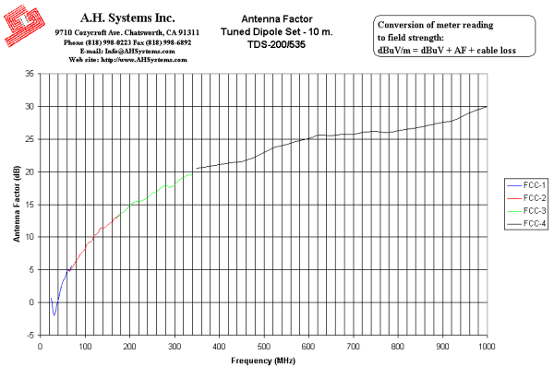
Innovation, Quality, and Performance
- Typical VSWR
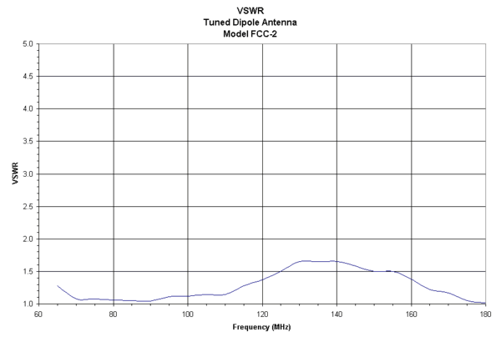
Innovation, Quality, and Performance
- Numeric Data
FCC-2 Tuned Dipole Antenna Data
3 Meter | 10 Meter
Antenna Page | VSWR Graph | AF Graph
3 Meter Antenna Factor
Frequency (MHz) | Element Length (L/2-in.) | Antenna Factor (dB/m) | Gain (dBi)
65 | 46 1/4 | 4.9 | 1.6
70 | 43 | 5.4 | 1.7
75 | 39 7/8 | 5.9 | 1.8
80 | 36 3/4 | 6.5 | 1.8
85 | 33 3/4 | 7.1 | 1.7
90 | 32 5/8 | 7.5 | 1.8
95 | 30 5/8 | 7.9 | 1.9
100 | 28 3/4 | 8.4 | 1.8
105 | 27 1/4 | 8.9 | 1.8
110 | 25 7/8 | 9.3 | 1.8
115 | 24 5/8 | 9.7 | 1.8
120 | 23 3/8 | 10.1 | 1.7
125 | 22 3/8 | 10.8 | 1.4
130 | 21 1/2 | 11.3 | 1.2
135 | 20 3/4 | 11.7 | 1.2
140 | 20 1/8 | 11.8 | 1.4
145 | 19 3/8 | 12.1 | 1.4
150 | 18 3/4 | 11.9 | 1.9
155 | 18 | 12.1 | 2.0
160 | 17 1/4 | 12.4 | 1.9
165 | 16 5/8 | 12.7 | 1.9
170 | 16 1/8 | 12.8 | 2.1
175 | 15 5/8 | 13.3 | 1.8
180 | 15 3/16 | 13.8 | 1.6

10 Meter Antenna Factor
Frequency (MHz) | Element Length (L/2-in.) | Antenna Factor (dB/m) | Gain (dBi)
65 | 46 1/4 | 4.7 | 1.8
70 | 43 | 5.2 | 1.9
75 | 39 7/8 | 5.8 | 1.9
80 | 36 3/4 | 6.4 | 1.9
85 | 33 3/4 | 6.8 | 2.0
90 | 32 5/8 | 7.4 | 1.9
95 | 30 5/8 | 7.8 | 2.0
100 | 28 3/4 | 8.3 | 1.9
105 | 27 1/4 | 8.9 | 1.8
110 | 25 7/8 | 9.2 | 1.9
115 | 24 5/8 | 9.5 | 2.0
120 | 23 3/8 | 10.2 | 1.6
125 | 22 3/8 | 10.4 | 1.8
130 | 21 1/2 | 10.9 | 1.6
135 | 20 3/4 | 11.4 | 1.5
140 | 20 1/8 | 11.3 | 1.9
145 | 19 3/8 | 11.5 | 2.0
150 | 18 3/4 | 11.8 | 2.0
155 | 18 | 12.1 | 2.0
160 | 17 1/4 | 12.3 | 2.0
165 | 16 5/8 | 12.8 | 1.8
170 | 16 1/8 | 13 | 1.9
175 | 15 5/8 | 13.2 | 1.9
180 | 15 3/16 | 13.7 | 1.7

