FCC-4 Tuned Dipole Antenna Data

More Information

- Typical Antenna Factor Plot - 3m
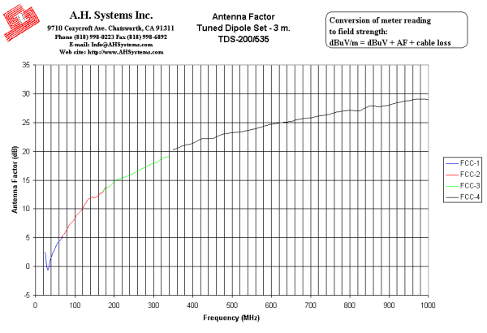
Innovation, Quality, and Performance
- Typical Antenna Factor Plot - 10m
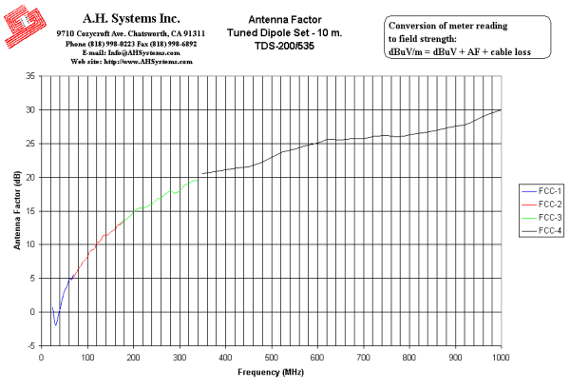
Innovation, Quality, and Performance
- Typical VSWR
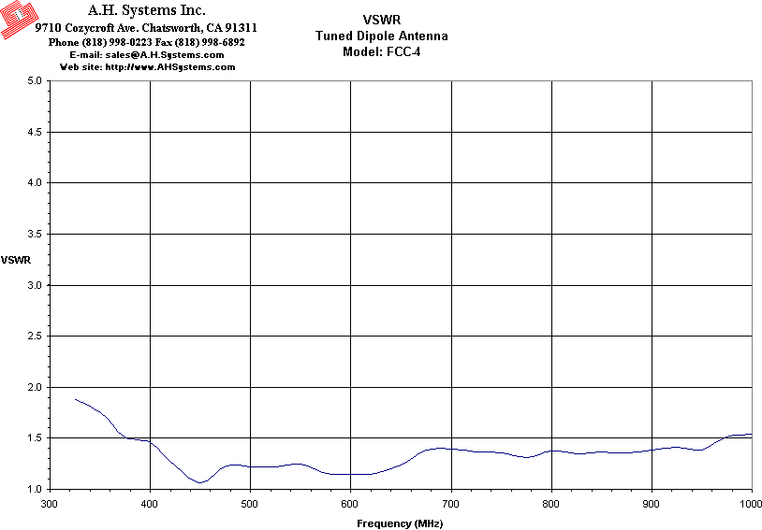
Innovation, Quality, and Performance
- Numeric Data
FCC-4 Tuned Dipole Antenna Data
3 Meter | 10 Meter
Antenna Page | VSWR Graph | AF Graph
3 Meter Antenna Factor
Frequency (MHz) | Element Length (L/2-in.) | Antenna Factor (dB/m) | Gain (dBi)
325 | 8 1/8 | 19.4 | 1.1
350 | 7 3/4 | 20.2 | 0.9
375 | 7 1/2 | 21 | 0.7
400 | 7 1/8 | 21.4 | 0.9
425 | 6 9/16 | 22.2 | 0.6
450 | 6 1/8 | 22.2 | 1.1
475 | 5 5/8 | 22.9 | 0.9
500 | 5 1/4 | 23.2 | 1.0
525 | 4 15/16 | 23.4 | 1.2
550 | 4 3/4 | 23.8 | 1.3
575 | 4 1/2 | 24.2 | 1.2
600 | 4 3/8 | 24.7 | 1.1
625 | 4 1/8 | 25 | 1.2
650 | 4 | 25.2 | 1.3
675 | 3 13/16 | 25.6 | 1.2
700 | 3 11/16 | 25.8 | 1.3
725 | 3 7/16 | 26.2 | 1.3
750 | 3 1/4 | 26.5 | 1.2
775 | 3 1/8 | 26.9 | 1.1
800 | 3 | 27.1 | 1.2
825 | 2 15/16 | 27 | 1.6
850 | 2 7/8 | 27.9 | 0.9
875 | 2 11/16 | 27.8 | 1.3
900 | 2 5/8 | 28 | 1.3
925 | 2 5/8 | 28.5 | 1.1
950 | 2 5/8 | 28.8 | 1.0
975 | 2 5/8 | 29.1 | 0.9
1000 | 2 5/8 | 29 | 1.2

10 Meter
Frequency (MHz) | Element Length (L/2-in.) | Antenna Factor (dB/m) | Gain (dBi)
325 | 8 1/8 | 19.8 | 0.7
350 | 7 3/4 | 20.5 | 0.6
375 | 7 1/2 | 20.8 | 0.9
400 | 7 1/8 | 21.1 | 1.2
425 | 6 9/16 | 21.4 | 1.4
450 | 6 1/8 | 21.5 | 1.8
475 | 5 5/8 | 22.1 | 1.7
500 | 5 1/4 | 22.9 | 1.3
525 | 4 15/16 | 23.8 | 0.8
550 | 4 3/4 | 24.1 | 1.0
575 | 4 1/2 | 24.7 | 0.7
600 | 4 3/8 | 25.1 | 0.7
625 | 4 1/8 | 25.6 | 0.6
650 | 4 | 25.5 | 1.0
675 | 3 13/16 | 25.7 | 1.1
700 | 3 11/16 | 25.7 | 1.4
725 | 3 7/16 | 26.1 | 1.4
750 | 3 1/4 | 26.2 | 1.5
775 | 3 1/8 | 26 | 2.0
800 | 3 | 26.3 | 2.0
825 | 2 15/16 | 26.6 | 2.0
850 | 2 7/8 | 26.8 | 2.0
875 | 2 11/16 | 27.2 | 1.9
900 | 2 5/8 | 27.6 | 1.7
925 | 2 5/8 | 27.9 | 1.7
950 | 2 5/8 | 28.7 | 1.1
975 | 2 5/8 | 29.4 | 0.6
1000 | 2 5/8 | 30 | 0.2

