TDS-535-2 Tuned Dipole Antenna Set Data

- Typical Antenna Factor Plot - 3m
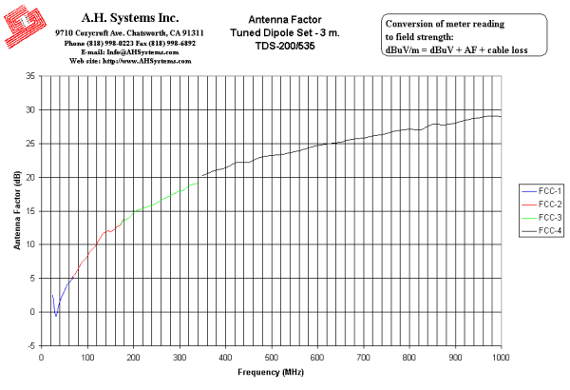
Innovation, Quality, and Performance
- Typical Antenna Factor Plot - 10m
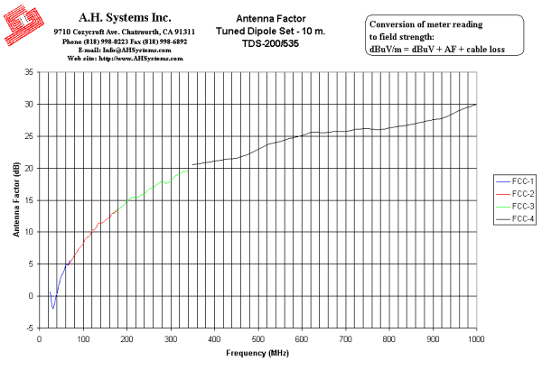
Innovation, Quality, and Performance
- Operation Manual (188Kb)

